SUBCOURSE EDITION
SS0657 8

Direct Installation
of
Antennas



US ARMY SINGLE CHANNEL RADIO OPERATOR COURSE
MOS 31C SKILL LEVELS 2 AND 3

DIRECT INSTALLATION OF ANTENNAS

SUBCOURSE NUMBER: SS0657

US Army Signal Center and Fort Gordon
Fort Gordon, Georgia
EDITION 8
2 CREDIT HOURS
NEW: 1988

GENERAL

The Direct Installation of Antennas subcourse is designed to provide you with the knowledge, skills, and abilities necessary for performing supervisory tasks related to the requirements for installation of antennas. This subcourse is presented in three lessons; each lesson corresponding to a terminal objective as indicated below.

Lesson 1: SELECTION OF ANTENNA SITES

TASK: Select the most suitable site for antenna installation.

CONDITIONS: Given a requirement, information extracted from FM 24-18, pencil, paper, and without supervision.

STANDARDS: Demonstrate competency of the task skills and knowledge by correctly responding to 70 percent of the multiple choice test covering the identification of siting considerations for antennas.

(This objective supports SM task numbers and titles 113-620-7070, Inspect Installed Radio Equipment; 113-611-1001, Select Team Radio Site; 113-611-1005, Select Radio Teletype Sites; and 113-599-1006, Issue Instructions for Installation of Radio Teletype Equipment.)

Whenever pronouns or other references denoting gender appear in this document, they are written to refer to either male or female unless otherwise indicated.

i

Lesson 2: DIRECT THE INSTALLATION OF COMMON HIGH FREQUENCY (HF) ANTENNAS.

TASK: Direct the installation of common high frequency (HF) antennas.

CONDITIONS: Given an azimuth, information extracted from TM 11-5815-334-10, FM 24-18, and TC 24-19, a pencil and paper and without supervision.

STANDARDS: Demonstrate competency of the task skills and knowledge by correctly responding to 75 percent of the multiple choice test covering Identifying the Characteristics and Directing this Installation of Common HF Antennas.

(This objective supports SM task number and title 113-596-7056, Direct Installation of Doublet Antenna.)

Lesson 3: DIRECT THE CONSTRUCTION AND INSTALLATION OF FIELD EXPEDIENT HF ANTENNAS.

TASK: Direct the construction and installation of field expedient HF antennas.

CONDITIONS: Given an azimuth, information extracted from TM 12-5815-334-10, FM 24-18, and TC 24-19, a pencil and paper and without supervision.

STANDARDS: Demonstrate competency of the task skills and knowledge by correctly responding to 80 percent of the multiple-choice text covering the materials used in construction of and directing the construction and installation of field expedient HF antennas.

(This objective supports SM task numbers and titles 113-611-1005, Select Radio Teletype Sites; 113-599-1006, Issue Instructions for Installation of Radio Teletype Equipment; and TS 113-620-7070, Inspect Installed Radio Equipment.)

ii

TABLE OF CONTENTS

Section Page

TITLE PAGE i

TABLE OF CONTENTS iii

INTRODUCTION vi

Lesson 1: SELECTION OF ANTENNA SITES 1

Learning Event 1: Antenna Siting Considerations. 1

Learning Event 2: Terrain Features that Affect
Communications 2

Learning Event 3: Using Terrain Features
to Mask Transmissions
from the Enemy 5

Practice Exercise
PERFORMANCE-ORIENTED (MULTIPLE-CHOICE) 10

Lesson 2: DIRECT INSTALLATION OF COMMON
HF ANTENNAS 12

Learning Event 1: Identify Common HF Antennas. . 12

Practice Exercise
PERFORMANCE-ORIENTED (MULTIPLE-CHOICE) 15

Learning Event 2: Direct Installation of
Common HF Antennas 17

Practice Exercise
PERFORMANCE-ORIENTED (MULTIPLE-CHOICE) 28

iii

Section Page

Lesson 3: DIRECT CONSTRUCTION AND INSTALLATION OF
FIELD EXPEDIENT HF ANTENNAS 30

Learning Event 1: Identify Field Expedient: Antenna
Materials 30

Practice Exercise
PERFORMANCE-ORIENTED (MULTIPLE-CHOICE) 39

Learning Event 2: Identify Types of Field Expedient
Antennas 41

Practice Exercise
PERFORMANCE-ORIENTED (MULTIPLE-CHOICE) 44

Learning Event 3: Direct Installation of Field
Expedient Antennas 46

Practice Exercise
PERFORMANCE-ORIENTED (MULTIPLE-CHOICE) 58

ANSWERS TO PRACTICE EXERCISES (PERFORMANCE-ORIENTED). 60

iv

INTRODUCTION

The Direct Installation of Antennas Subcourse, part of the US Army Single Channel Radio Operator MOS 31C, skill levels 2 and 3 course, is designed to familiarize you with the procedures for selecting a suitable antenna site, directing the installation of common HF antennas, and directing the construction and installation of field expedient HF antennas.

This subcourse consists of three lessons which are all related to the following terminal learning objective:

Performance-Oriented (Multiple-Choice) Terminal Learning Objective:

TASK: Direct the installation of common high frequency (HF) and field expedient antennas.

CONDITIONS: Given an azimuth, a pencil and paper and without supervision.

STANDARDS: Demonstrate competency of the task skills and knowledge by correctly responding to 70 percent of the multiple choice questions covering directing the installation of antennas.

vi

Lesson 1/Learning Event 1

LESSON 1

SELECTION OF ANTENNA SITES

TASK

Select the most suitable site for antenna installation.

CONDITIONS

Given a requirement and information extracted from FM 24-18.

STANDARDS

Demonstrate competency of the task skills and knowledge by correctly responding to 70 percent of the multiple-choice test covering siting considerations for antennas.

REFERENCE

FM 24-18, chapter 4

Learning Event 1:
ANTENNA SITING CONSIDERATIONS.

The reliability of radio communications depends largely on the selection of a good radio site. Since it is very difficult to select a site for a radio that satisfies all the technical, tactical, and security requirements, we compromise and select the best site of all those available. It is also good planning to select both a primary site and an alternate site. If, for some reason, radio communications cannot be established and maintained at the primary location, the radio equipment can be moved a short distance to the alternate site.

1. Siting an antenna is not a simple task, but requires some thought and decision making. The factors you must consider are--

a. Communications. Will the site you select allow communications with all of the stations you must talk to? This is the most important consideration, because your mission is to communicate. If the site you have selected WILL NOT allow you to communicate, you must select another.

b. Cover/concealment. It is always a good idea to conceal your activities and equipment from the enemy. You should try to conceal your antenna as well as you can, but, the better you conceal your antenna, the less efficiently it will work. This is because terrain features, foliage, and man-made features tend to block or absorb radio energy, thus reducing the effectiveness of the antenna system.

1

Lesson 1/Learning Event 2

c. Command post location. Enemy radio direction finding (RDF) capability is highly developed and so is their ability to analyze and use RDF information. You can be sure, that if you locate your antenna within the command post (CP) enemy RDF stations will locate the CP. When this happens the enemy can very easily call in artillery to destroy it. For this reason, you should try to locate your antenna away from the CP.

d. Enemy location. Some terrain features can be used to prevent the enemy from receiving your transmissions. These will be discussed in Learning Event 3 of this lesson.

e. Type of terrain.

(1) Generally, you will want to locate your antenna on high ground. This allows the radio waves to clear any obstacles in their paths.

(2) Dry earth makes a more difficult path for radio waves, while moist earth makes an easier one. This will be discussed in more detail in Learning Event 2 of this lesson.

2. The ideal site for an antenna would allow 100 percent communications reliability between your station and each of the other stations, allow complete cover and concealment, be several kilometers away from the CP, be located near terrain that would both enhance communications to friendly forces and mask or block radio waves from the enemy. As you can see, that is a tall order. Consequently, there will probably be some tradeoffs made. For example, if the stations you must communicate with are close by and communications are very good, you could trade some reliability for more cover and concealment. Not all tradeoffs are positive, though. You could find yourself in a situation where you have to sacrifice concealment of your antenna in order to ensure adequate reliability of communications.

Learning Event 2:
TERRAIN FEATURES THAT AFFECT COMMUNICATIONS.

1. After the radio signal leaves the transmitting antenna, you must be concerned with the amount of radiated energy that is lost along the transmission path. Selecting the transmission path with the least radiation loss ensures that more energy will be transferred to the receiving antenna.

2. For maximum transfer of energy, the radiating antenna must be the proper length for the operating frequency. The local terrain determines, in part, the radiation pattern and therefore affects the directivity of the antenna and the possible range of the set in the desired direction. If possible, several variations in the

2
Lesson 1/Learning Event 2

physical position of the antenna should be tried to determine the best operating position to radiate the greatest amount of energy in the desired direction.

3. Ground-wave transmission is used for most field radio communications. The range of the ground-wave becomes correspondingly shorter as the operating frequency of the transmitter is increased through the applicable portions of the medium-frequency band (300-3000 kHz) to the high-frequency band (3-30 MHz). When the transmitter is operating at frequencies above 30 MHz, its range is limited generally to slightly more than line of sight. Military high-frequency (HF) transmitters generally cover frequencies from 2.000 to 30.000 MHz.

4. Effects of Terrain.

a. The type of terrain between two field radio sets determines ground conductivity and affects the ground-wave. Flat prairie country has high conductivity and there is little absorption of the ground-wave by the earth. Large bodies of water also have high conductivity. Mountainous, rugged, and broken country usually has low conductivity. In areas where there are large mineral deposits, and in deep ravines and valleys, the ground-wave may be absorbed completely by the soil.

b. Dry ground has low conductivity and limits the range of the radio set. If possible, locate the station near moist ground, which has much greater conductivity. Water, and in particular salt water, greatly increases the distances that can be covered.

c. Trees with heavy foliage absorb radio waves, and leafy trees have more of an adverse effect than evergreens. Keep the antenna clear of all foliage and dense brush; but try to use available trees and shrubs for cover and concealment and for screening from enemy jamming. DO NOT allow the antenna wire to come into contact with any type of foliage.

d. Hills and mountains between stations normally limit the range of radio sets. In mountainous or hilly terrain, select positions relatively high on the slopes (Figure 1). Avoid a location at the base of a cliff or in a deep ravine or valley (Figure 2). For operation at frequencies above 30 MHz, and whenever possible, select a position that will allow line-of-sight communications. Try to avoid locations which provide the enemy with a jamming capability, visual sighting, or easy interception.

e. Avoid open crests of hills and mountains. A position protected from enemy fire just behind the crest gives better concealment and sometimes provides better communications.

3

Lesson 1/Learning Event 2

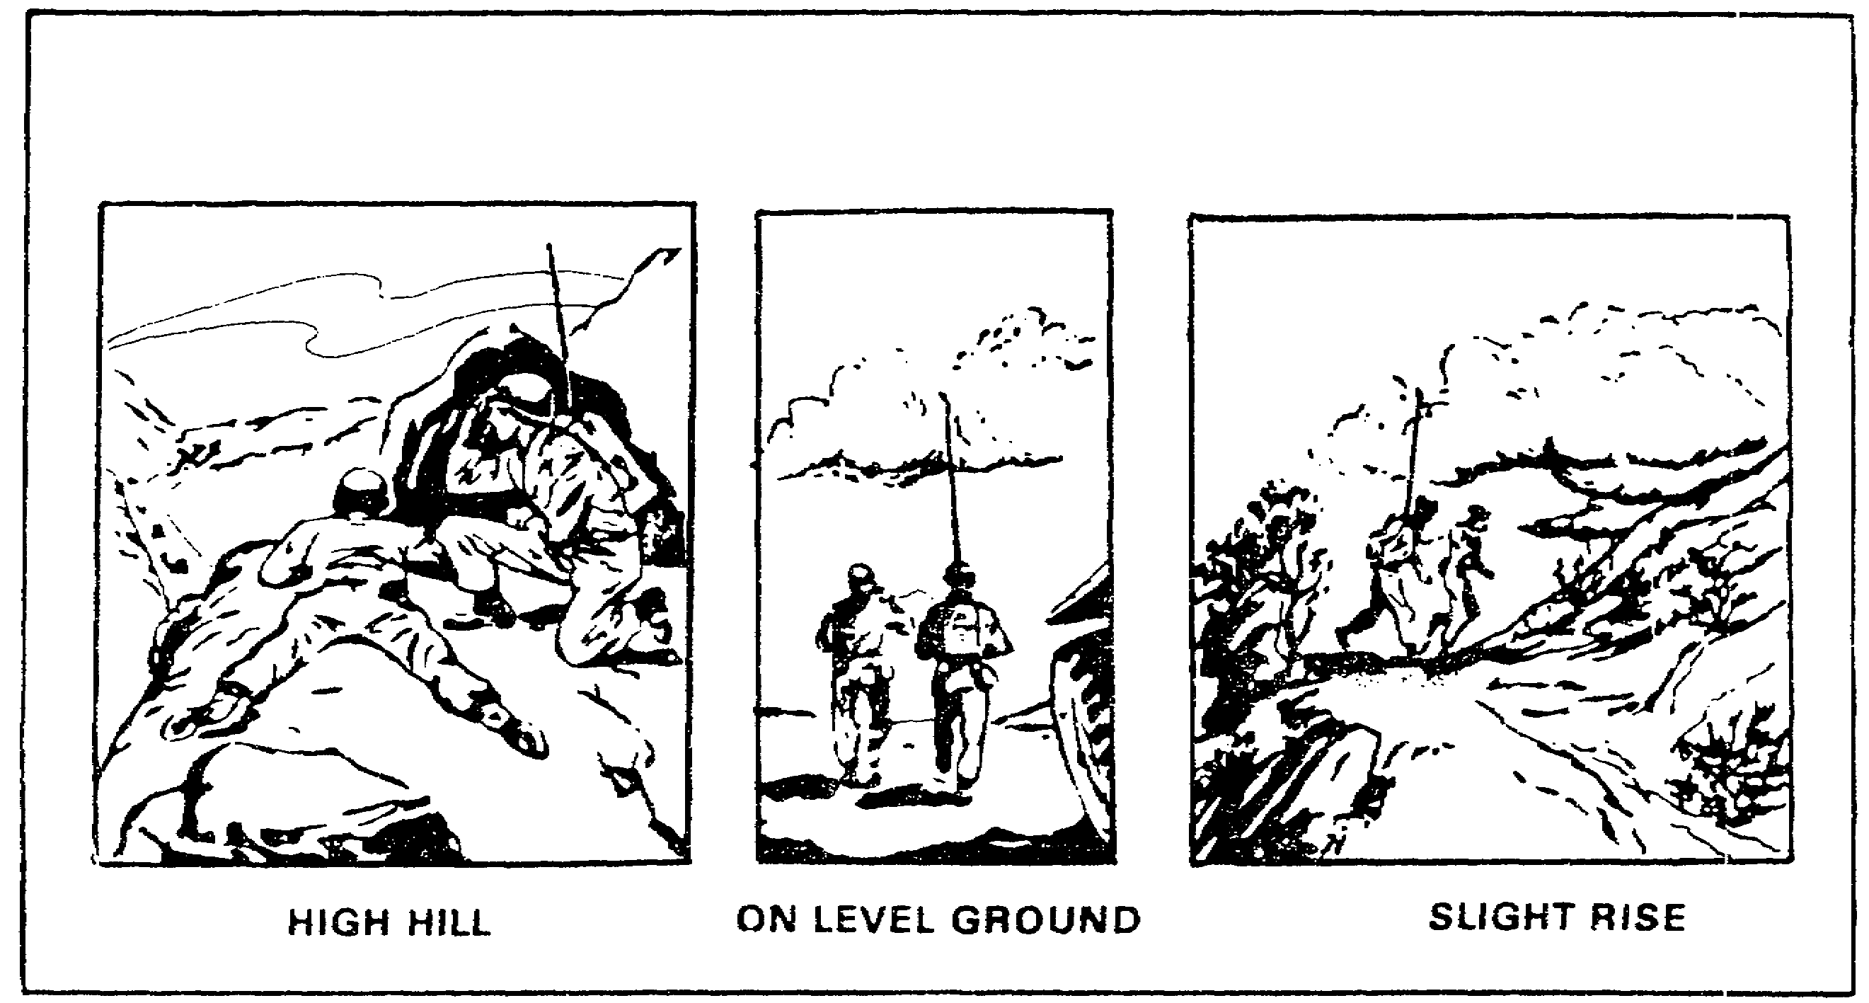

FIGURE 1. GOOD SITES FOR RADIO COMMUNICATIONS.

5. Manmade Features.

a. Do not select an antenna position in a tunnel or beneath an underpass or steel bridge (Figure 2). Transmission and reception under these conditions are almost impossible because of high absorption of RF energy.

b. Buildings located between radio stations, particularly steel and reinforced concrete structures, hinder transmission and reception. You should, however, try to use buildings to camouflage your antenna from the enemy. You can also use them to mask or block your transmissions from the enemy.

c. Avoid all types of pole wire lines, such as telephone, telegraph, and high-tension powerlines, when selecting a site for a radio station. Wire lines absorb power from radiating antennas located in their vicinity. They also introduce hum and noise interference in receiving antennas.

d. Avoid positions adjacent to heavily traveled roads and highways. In addition to the noise and confusion caused by tanks and trucks, ignition systems in these vehicles may cause electrical interference.

4

Lesson 1/Learning Event 3

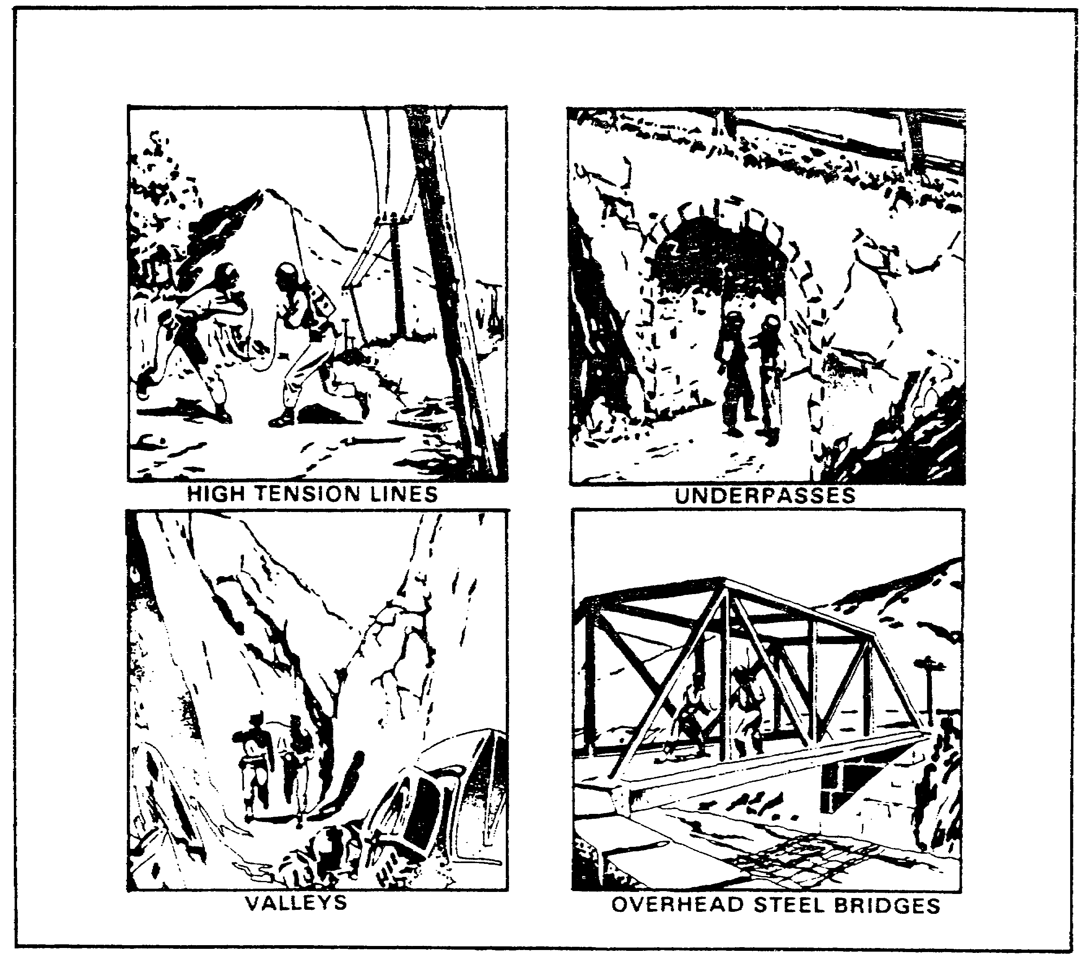

FIGURE 2. POOR SITES FOR RADIO COMMUNICATIONS.

e. Do not locate battery-charging units and generators close to the radio station.

f. Do not locate radio stations close to each other.

Learning Event 3:
USING TERRAIN FEATURES TO MASK TRANSMISSIONS FROM THE ENEMY.

1. One of the greatest defenses against enemy interception of your radio transmissions is denying him the knowledge that you are transmitting at all. The most effective way to accomplish this is through the use of directional antennas and "terrain masking".

5

Lesson 1/Learning Event 3

a. Directional antennas place most of the signal strength in only one or two directions. By properly orientating the antenna, most of your radiation will be away from the enemy and to the station(s) to whom you want to talk.

b. The use of the AN/GRA-50 Antenna causes a bi-directional radiation path to be established broadside to the antenna. (See Figure 3.)

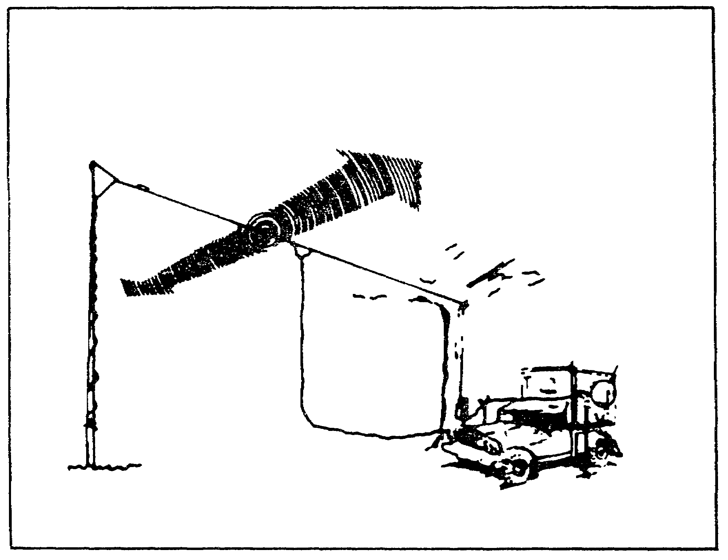

FIGURE 3. AN/GRA-50 RADIATION PATTERN.

c. Unfortunately, sometimes correctly orienting your antenna to talk to a rear station causes the other side to radiate into enemy held territory. Here is where terrain masking must be used.

d. Terrain masking is nothing more than placing a hill or some other radio wave blocking or absorbing medium between you and the enemy. Consider the figures and explanations which follow:

6

Lesson 1/Learning Event 3

e. Orienting the antenna as shown in Figure 4 supplies good contact with the units on both sides of you while effectively denying information to the enemy in the background. This is because radiation from the ends of a doublet antenna is much less than the radiation broadside to the antenna.

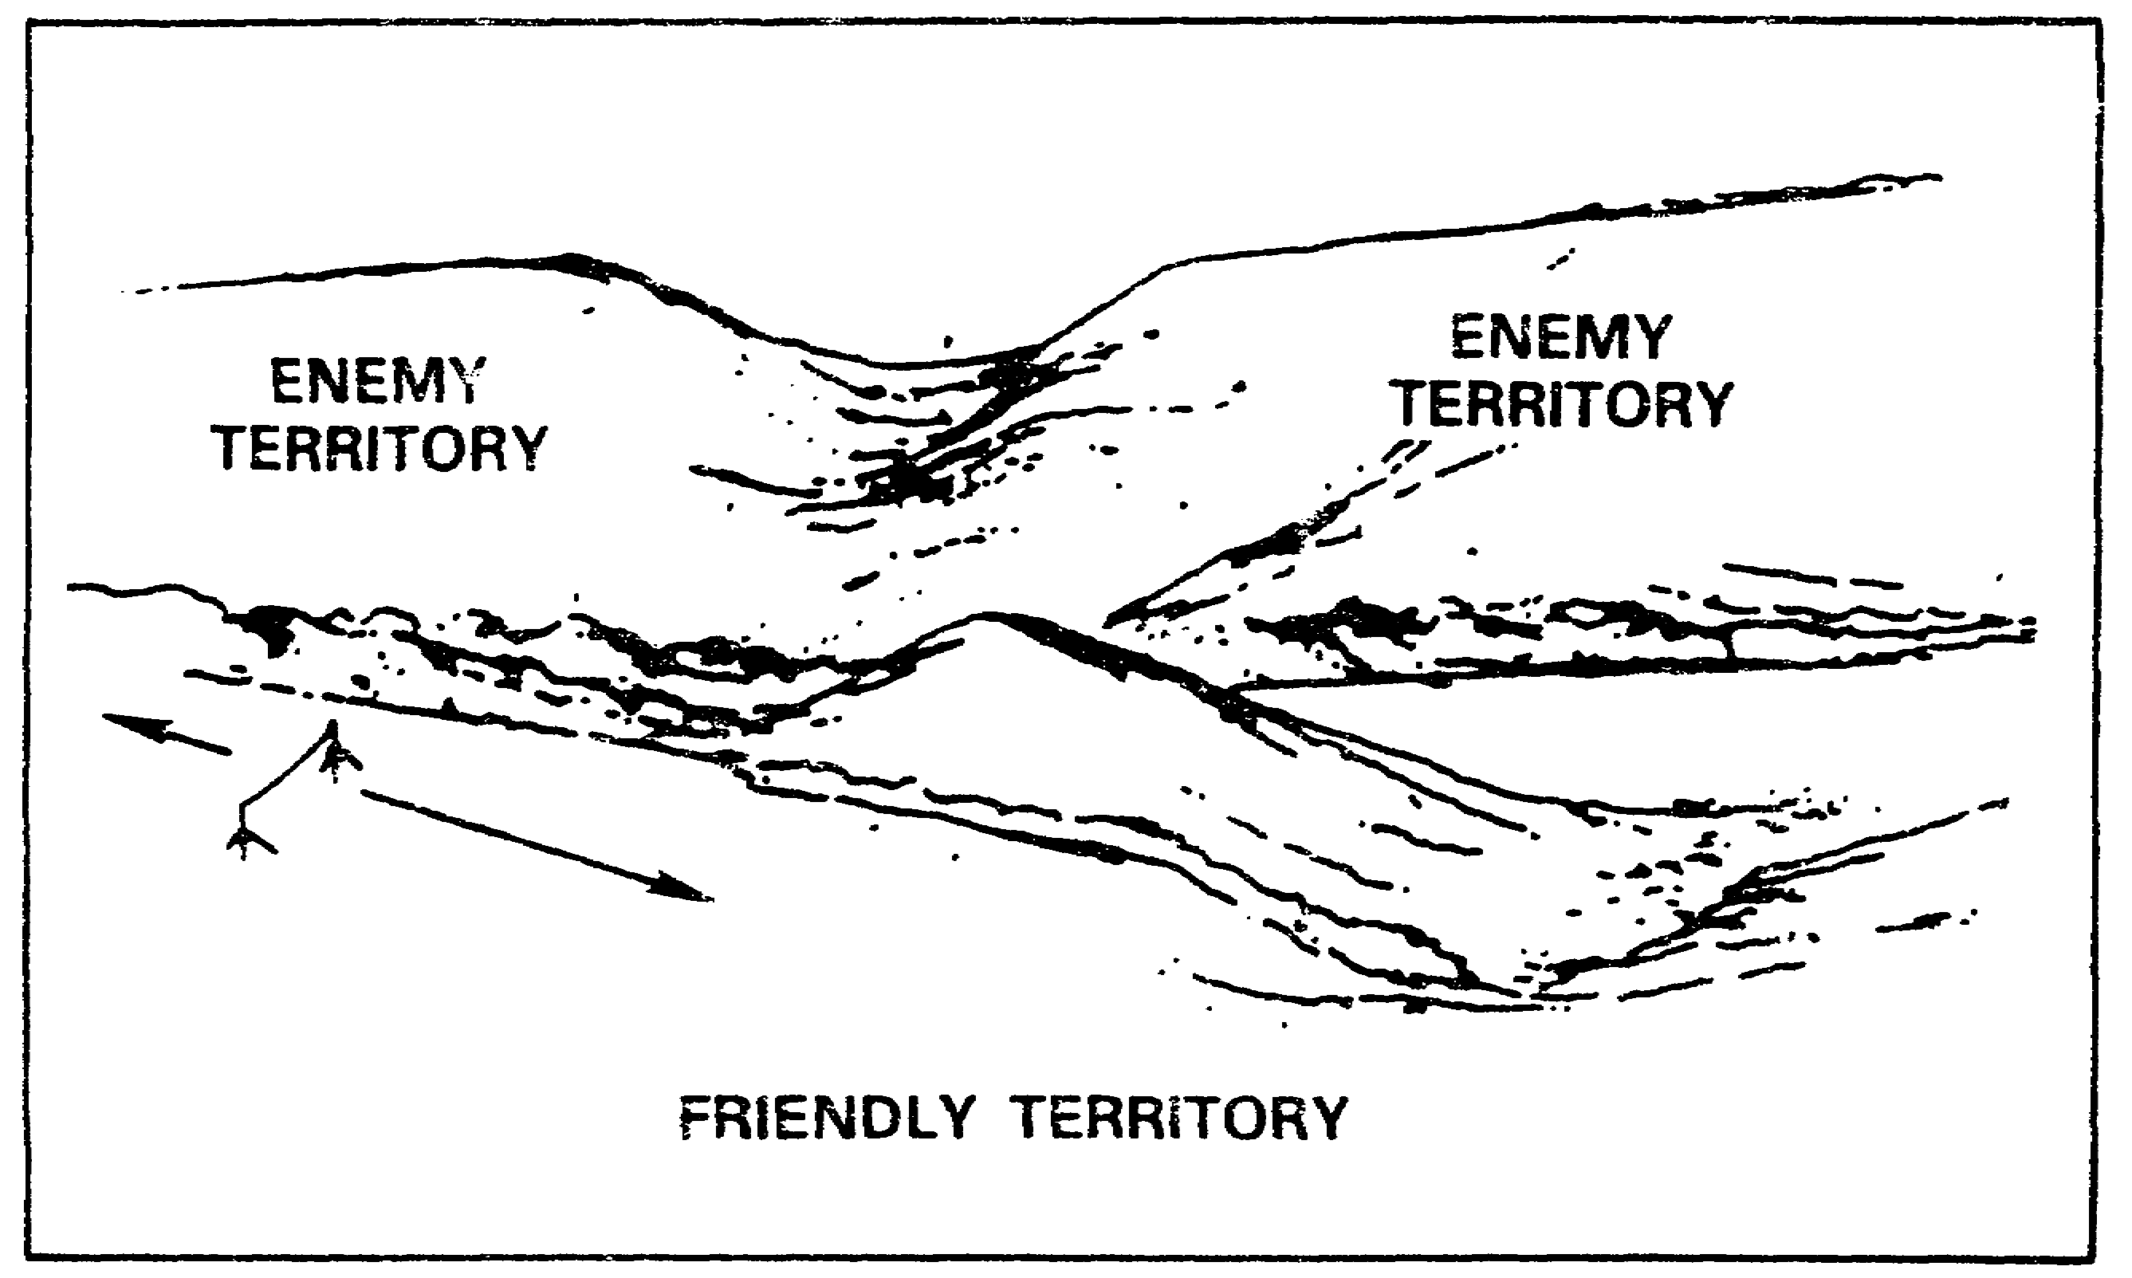

FIGURE 4. AN/GRA-50 ORIENTED TO COMMUNICATE TO THE SIDES.

7

Lesson 1/Learning Event 3

f. Now your operator has to talk to the rear area. As you can see from Figure 5, while he has good orientation toward the station he wants to talk to, he is also radiating his signal directly to the enemy.

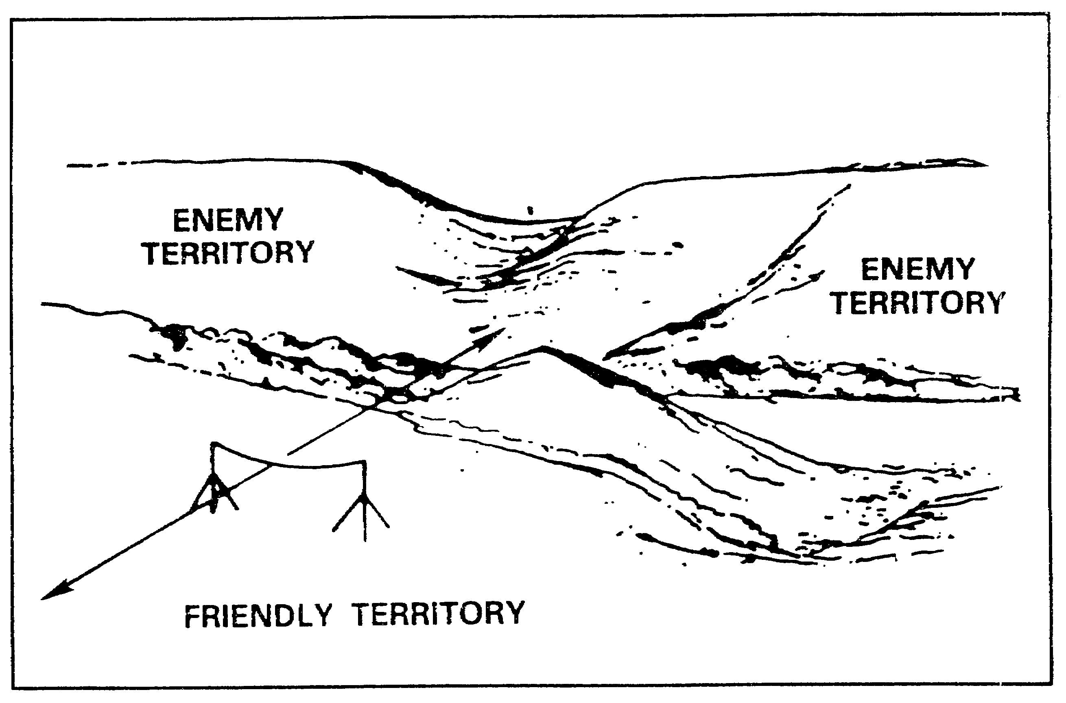

FIGURE 5. TRANSMITTED SIGNAL BEING RADIATED TO THE ENEMY.

8

Lesson 1/Learning Event 3

g. By moving the antenna behind the hill as shown in Figure 6, your operator can still talk to the rear, but now the hill absorbs some of the RF energy that was radiated toward the enemy. Your operator, through the use of terrain masking, has now denied the enemy information that he is transmitting, yet still maintains contact with the other stations in his net.

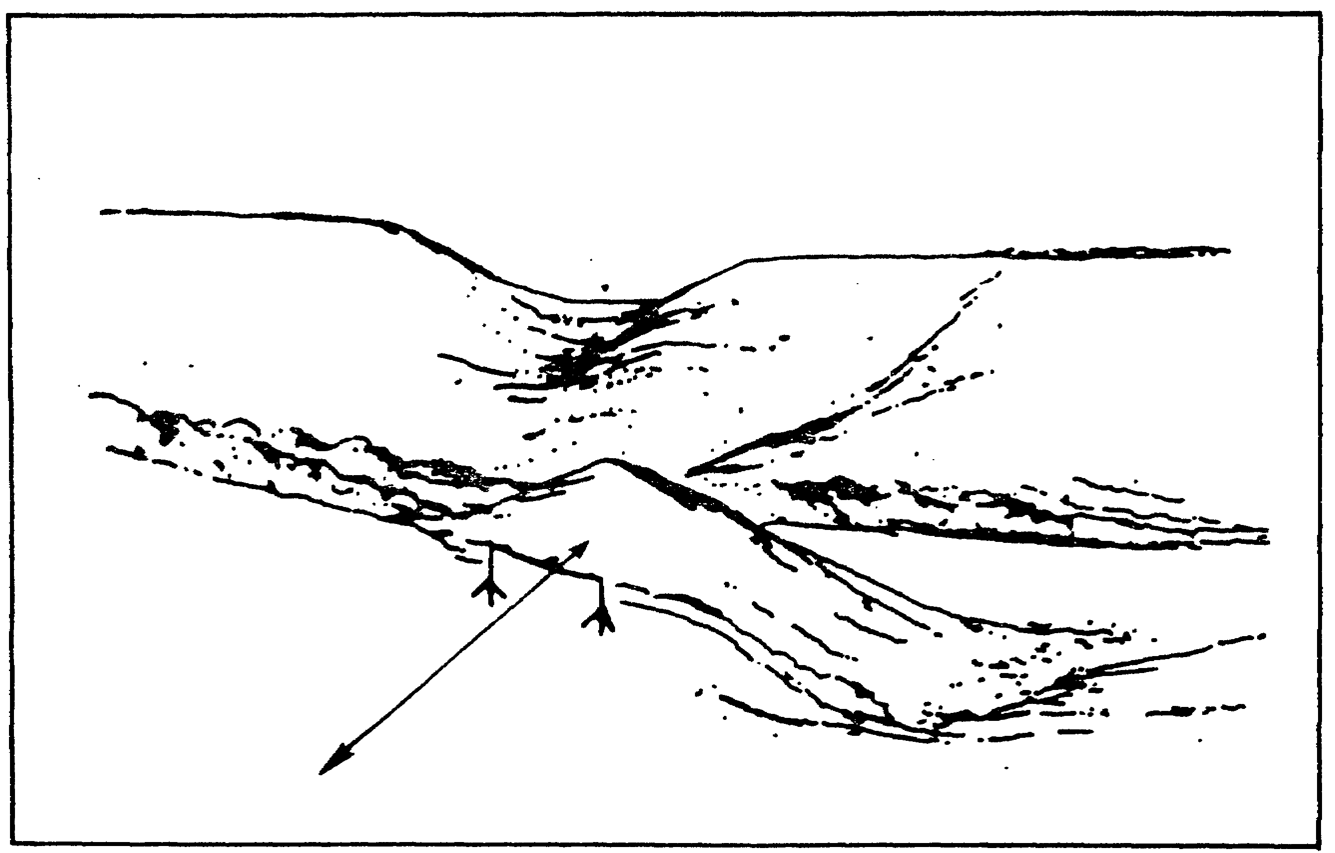

FIGURE 6. USE OF TERRAIN FEATURES TO MASK
TRANSMISSIONS FROM THE ENEMY.

2. The same techniques can be used with omnidirectional antennas, such as the whip antenna, to deny the enemy the ability to listen to your radio transmissions. However, since omnidirectional antennas radiate in ALL directions, you will have to be more careful in your selection of an antenna site. You will need to try to mask your transmissions in ALL undesired directions instead of just one.

9

LESSON 1

PRACTICE EXERCISE

(PERFORMANCE-ORIENTED)

TASK: Selection of Antenna Sites

CONDITIONS: Given a requirement, information extracted from FM 24-18, pencil, paper, and without supervision.

STANDARDS: Demonstrate competency by correctly answering 70 percent of the multiple-choice questions covering the identification of siting considerations for antennas.

INSTRUCTIONS:

In each of the following questions, SELECT the one answer that BEST completes the statement or answers the question. Indicate your response by circling the correct letter below.

1. Why is it important to locate your radio and antenna away from the command post?

a. To provide more parking space in the CP.

b. To prevent enemy direction finders from locating the CP.

c. To keep the CP as small as possible.

d. To keep the number of vehicles in the CP to a minimum.

2. In order to ensure the most reliable transmission path, what type of ground should you select between your transmitting antenna and the receiving station?

a. With the lowest altitude.

b. With the highest altitude.

c. With the lowest conductivity.

d. With the highest conductivity.

10

3. You wish to ensure the best ground wave distance. Which of the following would you select for your antenna site?

a. High ground.

b. Low ground.

c. Dry ground.

d. Rocky ground.

4. Which of the following locations provide the best communications while masking your transmissions from the enemy?

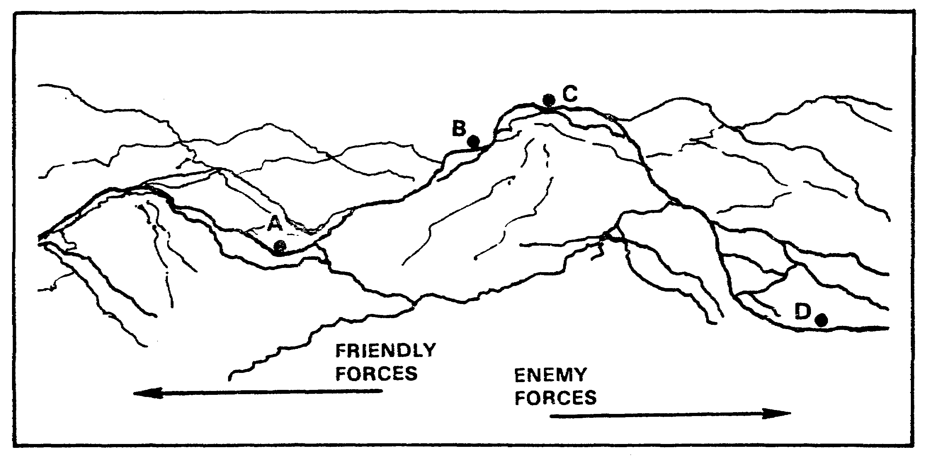

11

Lesson 2/Learning Event 1

LESSON 2

DIRECT INSTALLATION OF COMMON HF ANTENNAS

TASK

Direct the installation of common high frequency (HF) antennas.

CONDITIONS

Given a requirement, an azimuth, and information extracted from TM 11-5815-334-10, FM 24-18, and TC 24-19.

STANDARDS

Demonstrate competency and knowledge by correctly responding to 70 percent of the multiple choice questions covering identifying the characteristics and directing the installation of common EF antennas.

REFERENCES

TM 11-5815-334-10, Chapter 2; FM 24-18, Chapter 3.

Learning Event 1:
IDENTIFY COMMON HF ANTENNAS.

NOTE: All radios, whether transmitting or receiving, require some sort of antenna. The installation of an antenna used by a transmitter is more critical than the installation of one used only by a receiver. Since single-channel radios normally transmit and receive on the same antenna, this means that the antennas you direct to be installed must be installed to the stricter standards of a transmitter antenna.

1. Radiation Patterns and Transmission Ranges.

a. The radio signals radiated by an antenna form an electromagnetic field having a definite pattern, depending on the type of antenna used. This radiation pattern is used to show the directional characteristics of an antenna.

b. A vertical antenna theoretically radiates energy equally in all directions. This is called an omnidirectional radiation pattern. The whip antenna used by single channel radio operators has this type of radiation pattern.

c. At the lower frequencies where wavelengths are longer, it is impractical to use resonant length (1/4.wavelength) vertical antennas with portable radio systems, especially those used with

12
Lesson 2/Learning Event 1

vehicular installations. As a result, a compromise must be made between portability and the antenna length. An antenna length of 4.5 meters (15 feet) is generally used for tactical whip antennas.

d. Vertical antennas, such as the tactical whip antenna, generally have a low radiation angle and vertical polarization. This means that they provide primarily ground-wave radio service out to a distance of about 32 kilometers (20 miles).

e. The operation of Hertz antennas, such as the AN/GRA-50 and the segmented wire or multiple frequency dipole, is based on the fact that the frequency to which any wire will electrically tune depends directly upon its physical length. The basic Hertz antenna is center fed and its total wire length is approximately equal to one half of the wavelength of the signal to be transmitted.

f. This type of antenna, which is also known as a doublet or dipole, is an ungrounded half-wave antenna. It can be mounted in either a vertical, horizontal or sloping position. At the lower frequencies of the HF band it is impractical to mount a Hertz antenna vertically because of the length of the antenna, consequently, tactical Hertz antennas are generally mounted horizontally or in a sloping position.

g. When installed more than 1/4 wavelength above the ground, horizontal Hertz antennas have a bidirectional radiation pattern broadside to the length of the wire. They also have a relatively low radiation angle. This makes horizontal Hertz antennas suitable for skywave service at distances greater than 100 miles. This is the primary use for Hertz antennas, although they can be used over shorter distances.

2. Specific Antenna Equipment. Complete details on directing the construction and installation of these pieces of equipment will be discussed in Learning Event 2 of this lesson.

a. Whip antenna. The whip antenna is an end fed, 4.5 meter (15 foot) vertical antenna. To achieve this length five antenna sections are used: three MS-116 sections, one MS-117 section, and one MS-118 section. Once the antenna is assembled and attached to the AB-652 antenna base, it constitutes an operable whip antenna.

b. AN/GRA-50 doublet antenna system - The AN/GRA-50 is an adjustable, reusable antenna system designed to be used as a center fed half-wave Hertz antenna. The antenna wire is contained on small reels that allow the length to be adjusted to any frequency from 2 to 30 MHz.

c. AB-155/U antenna mast kit - The AB-155/U is a portable 40 foot high antenna mast that can quickly and easily be assembled for use as an antenna support in a tactical environment.

13

Lesson 2/Learning Event 1

d. AB-1089/U tripod adaptor - When used with the AB-155/U antenna mast, the AB-1089/U tripod adaptor allows even faster assembly and disassembly time for an antenna support. When assembled without guy ropes, this antenna mast is capable of withstanding winds up to 25 miles per hour. If you expect higher winds, then the mast must be guyed.

14

LESSON 2

LEARNING EVENT 1

PRACTICE EXERCISE

(PERFORMANCE-ORIENTED)

TASK: Identify the characteristics of common high frequency (HF) antennas.

CONDITIONS: Given information extracted from TM 11-5815-334-10 and FM 24-18, a pencil, paper and without supervision.

STANDARDS: Performance oriented. Demonstrate competency and knowledge by correctly answering 70 percent of the multiple choice questions covering identifying characteristics of common HF antennas.

INSTRUCTIONS:

In each of the following questions, SELECT the one answer that BEST completes the statement or answers the question. Indicate your response by circling the correct letter below.

1. What type of radiation pattern does a whip antenna have?

a. Unidirectional.

b. Bidirectional.

c. Omnidirectional.

d. Superdirectional.

2. How many whip sections are required for a completely erected whip antenna?

a. Three.

b. Four.

c. Five.

d. Six.

15

3. What is the primary type of radio service you provide when you use a doublet antenna?

a. Ground wave, less than 20 miles.

b. Ground wave, greater than 20 miles.

c. Sky wave, less than 100 miles.

d. Sky wave, greater than 100 miles.

4. What is the height of a correctly installed AB-155/U antenna mast?

a. 30 feet.

b. 35 feet.

c. 40 feet.

d. 45 feet.

16

Lesson 2/Learning Event 2

Learning Event 2:
DIRECT INSTALLATION OF COMMON HF ANTENNAS.

1. WHIP ANTENNA - Of all the antennas you can expect to use, the whip antenna is the easiest to assemble and disassemble. There are only a few things you need to check to ensure proper installation:

a. Number of antenna elements - Check to ensure that the whip is constructed with three MS-116, one MS-117 and one MS-118.

b. Antenna cover - Ensure that the antenna cover is in place and clamped down.

c. Antenna tip - The antenna tip is a safety feature. Ensure that it is in place and securely fastened to the MS-118 mast section. Also make sure that the transmit antenna (the one tied down towards the rear) is tied down so its tip is about 8 feet above the ground.

d. Antenna bracket - Ensure that the bracket is vertical and both locking pins are in place.

e. Lead in - Ensure that the lead in is properly attached to the AB-652 antenna base and to the radio set.

f. Mobile operations - If you will be operating mobile, ensure that your antennas are tied down securely. See Figure 7.

2. DOUBLET ANTENNAS - We will discuss two types of doublet antennas, the AN/GRA-50 and the multiple frequency or segmented wire dipole. Both work the same, that is, they are half-wave antennas and radiate broadside to the length of the wire. The formula for calculating the length of both of these antennas is:

Length (feet) = 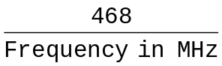

This will give the TOTAL length of the antenna and must be divided in half to find the length of each side.

17

Lesson 2/Learning Event 2

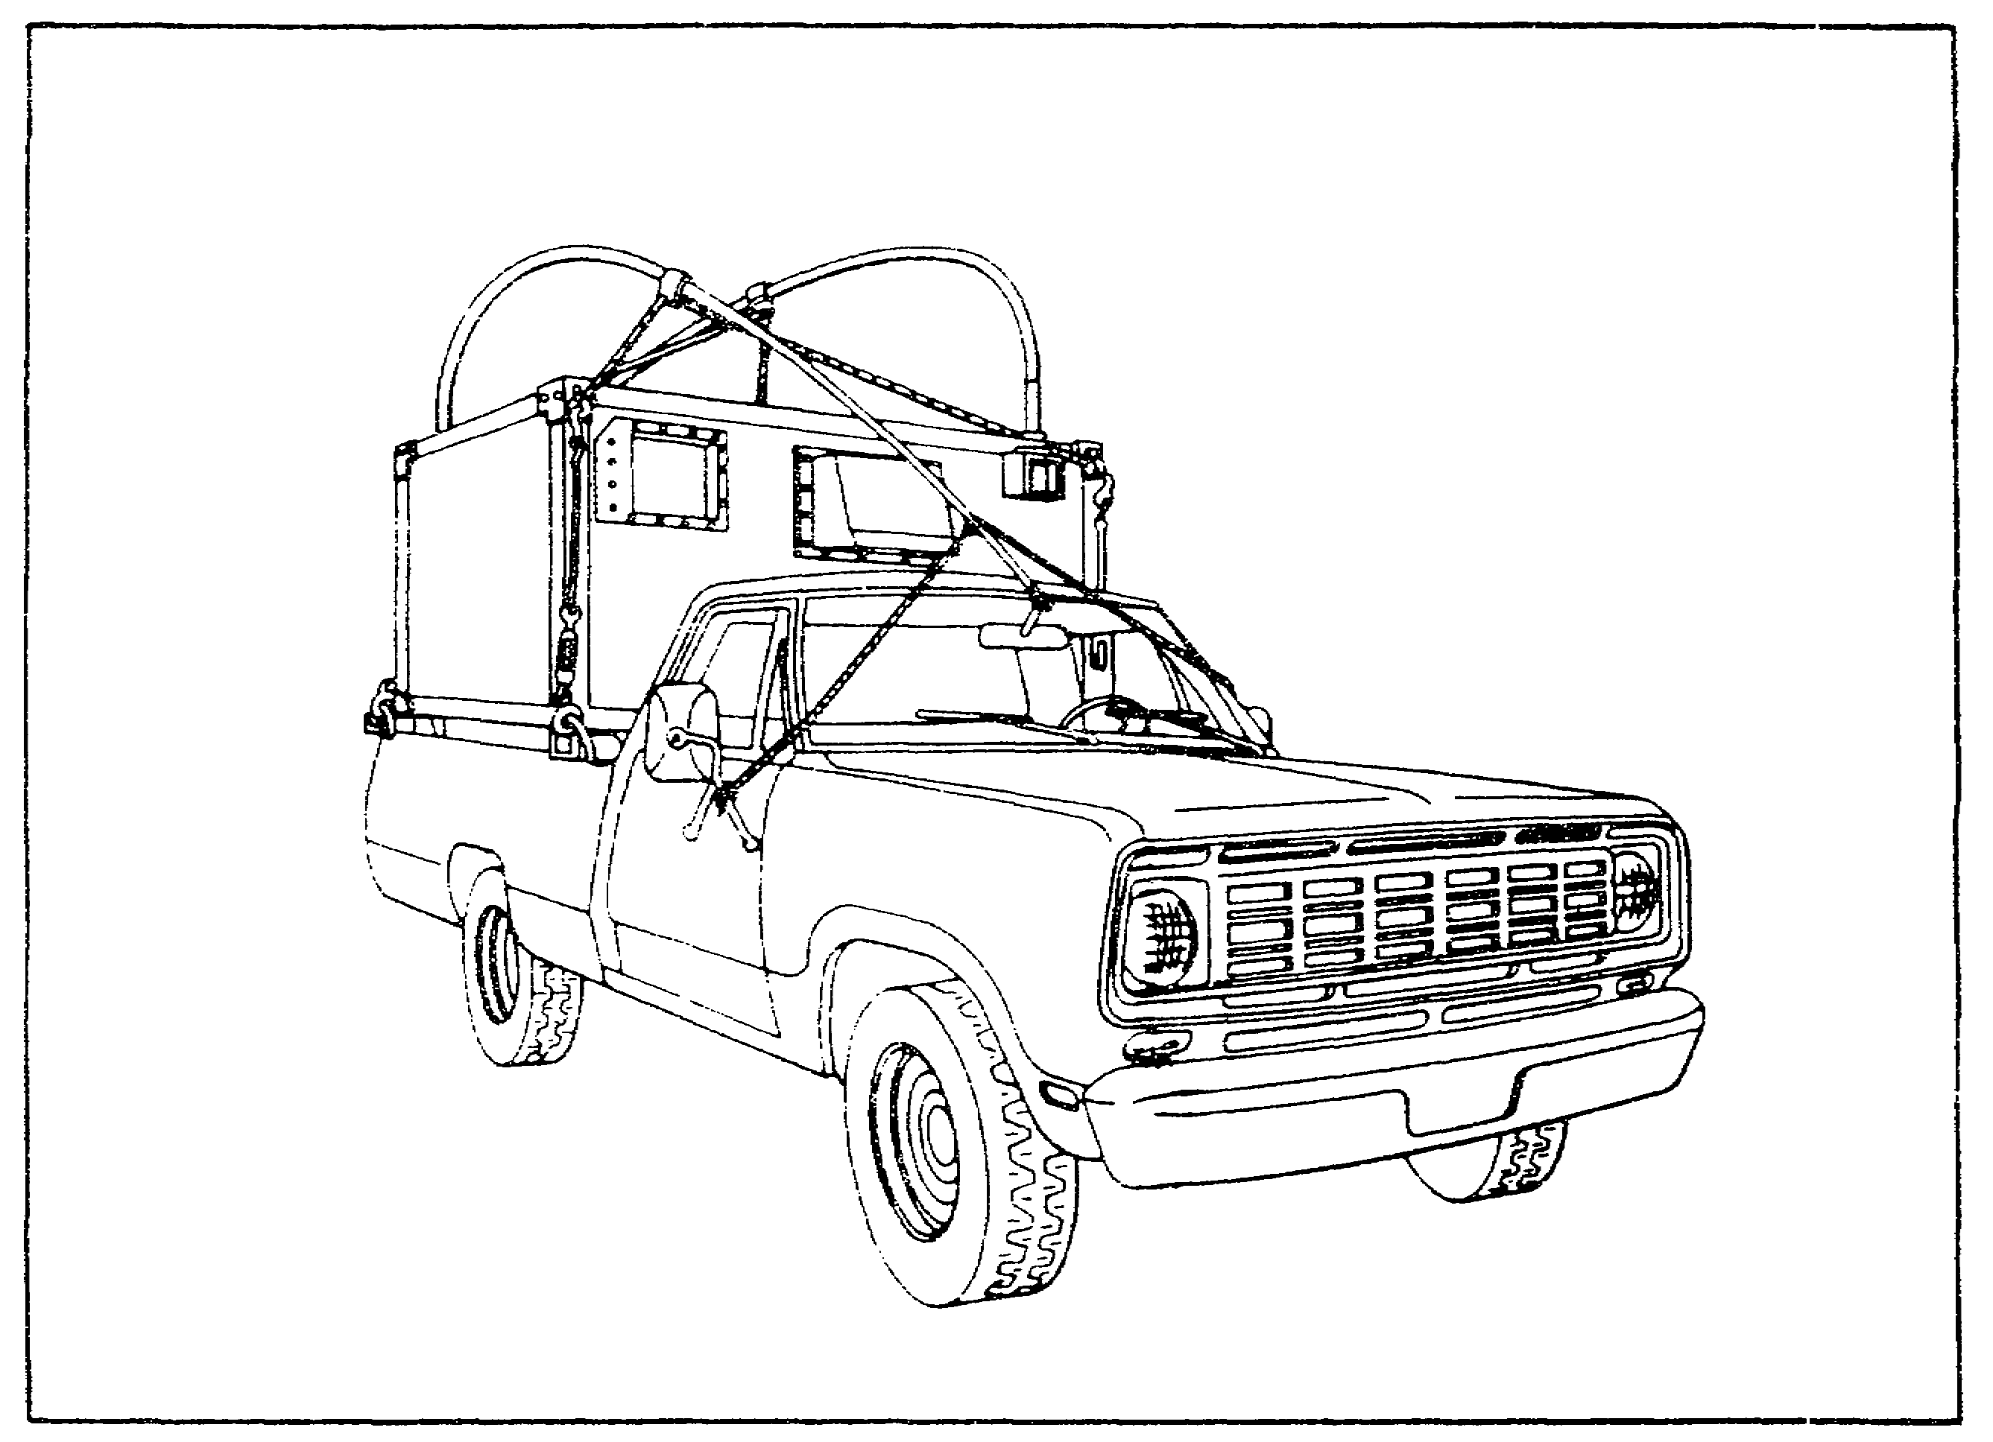

Figure 7. WHIP ANTENNAS TIED DOWN FOR MOBILE OPERATION.

a. AN/GRA-50.

(1) Prior to deployment, you should always check your equipment for completeness and serviceability. The checks for an AN/GRA-50 are:

(a) Check antenna reel and wire for breaks and kinks.

(b) Check RF cable CG-678/J for cuts, breaks and to ensure that both connectors are securely attached to the cable.

(c) Ensure that your measuring tape is present and serviceable.

(d) Check the halyards to make sure they aren't excessively frayed.

18

Lesson 2/Learning Event 2

(e) Check the IL-4 insulator to ensure that both wingnuts are operable, and that the RF connector is serviceable. In particular, check the center pin of the RF connector to ensure that it isn't missing or broken.

(2) As the antenna is constructed and installed, you need to do the following:

(a) Check that the antenna length is measured properly. See Figure 8.

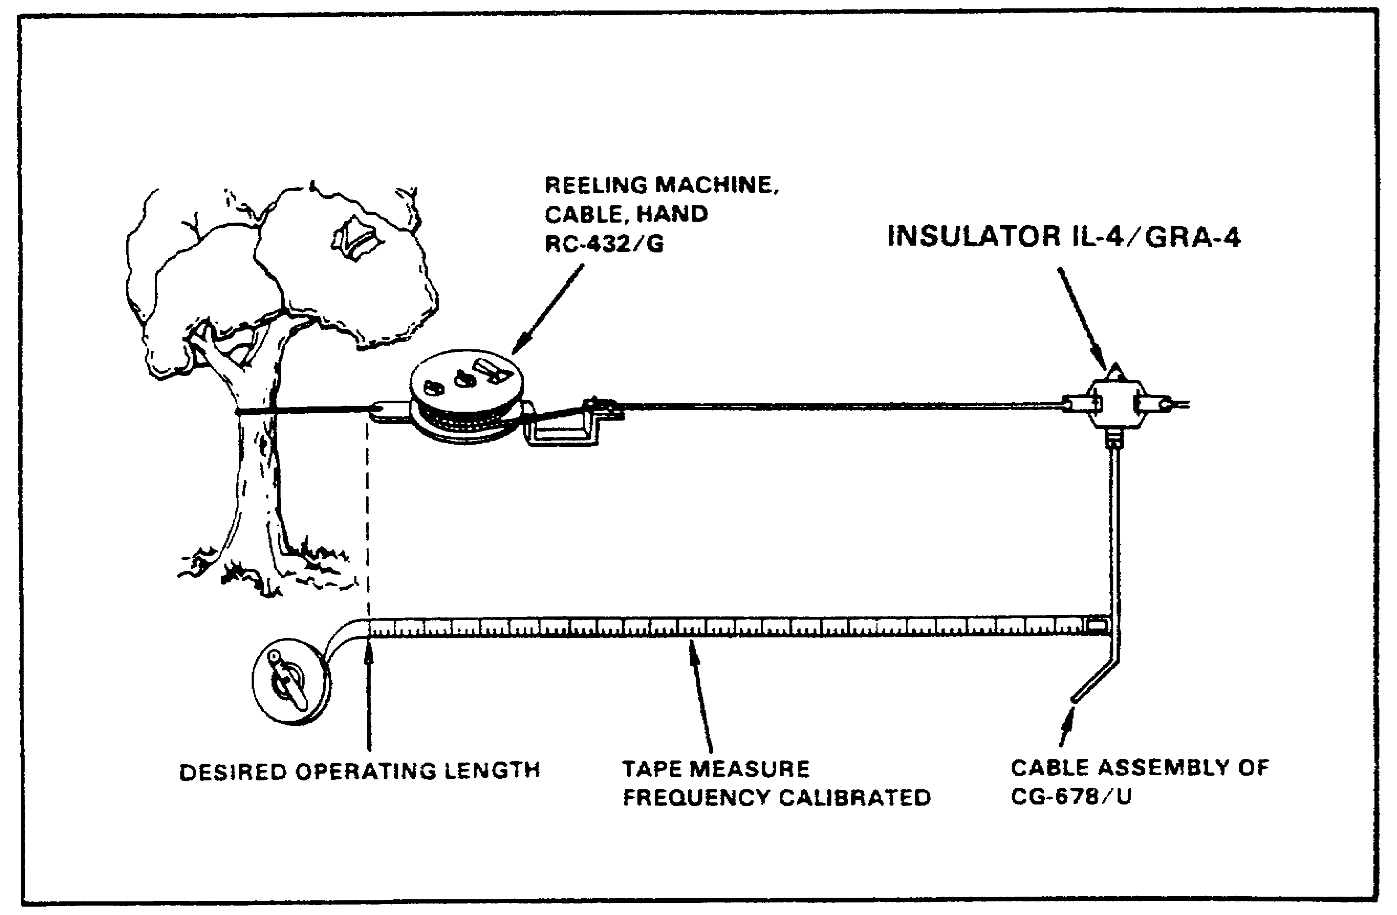

FIGURE 8. MEASURING THE LENGTH OF AN/GRA-50 ANTENNAS.

(b) Check that antenna is laid out broadside to the azimuth you wish to communicate on.

(c) Lay out your antenna BEFORE erecting AB-155/U antenna masts. This will ensure that you place your masts properly to obtain the desired azimuth. Also, ensure that you leave enough space between the masts to allow you to construct and install an antenna for the LOWEST frequency you expect to operate on.

19

Lesson 2/Learning Event 2

(d) Ensure that the antenna is allowed to sag approximately 24 inches lower than the end supports. This reduces the amount of strain on the antenna wire and prevents breaking.

(e) Ensure that a strain relief is placed on the center insulator and RF cable as illustrated in Figure 9. Once the cable is looped as shown, tape the cable to the RF connector at the place indicated. This will help prevent the cable from being pulled out of the connector.

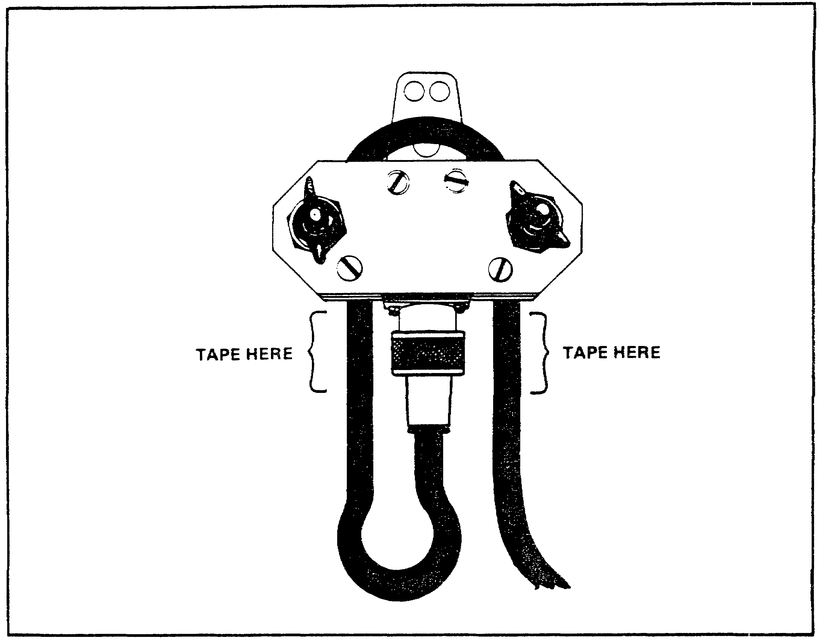

FIGURE 9. COAXIAL CABLE STRAIN RELIEF.

b. SEGMENTED WIRE ANTENNA (MULTIPLE FREQUENCY DIPOLE) - This half-wave antenna allows you to use one antenna to operate on up to four frequencies. This is accomplished by assembling different lengths of antenna wire separated by strain insulators. You achieve the desired frequency by connecting these lengths of wire with jumpers across the insulators.

20

Lesson 2/Learning Event 2

(1) Prior to deployment you will need to ensure that you have the following materials:

(a) Sufficient W-l stranded copper antenna wire. To calculate how much you will need, figure out the length of the antenna for your LOWEST frequency and add 3 feet for each frequency you plan on using. For example, assume that you have to construct an antenna for three frequencies, the lowest of which is 4.680 MHz. Using the formula in paragraph 2 on page 17, you calculate the length of the 4.680 MHz antenna to be 100 feet. Next you add 3 feet to the length for each of the three frequencies you plan on using; that is, 3 times 3 feet or 9 feet. This gives you a total of 109 feet of wire that you will need to construct this antenna.

(b) Two strain insulators for each frequency you will operate on.

(c) Lead in. You will need either one RF cable assembly CG-692/U or one RF cable assembly CG-678/U with one center insulator IL-4/GRA-4.

(d) Four splice connectors (Burndy KS90 split bolts or equivalent) for each frequency you will operate on.

(e) Halyards - You will need one halyard for each support you require for your antenna.

(f) Measuring tape.

(g) Linemans pliers or diagonal cutters to cut the wire segments to the proper length.

(2) The things to check during the construction and installation of the segmented wire antenna are the same as for the AN/GRA-50 with the following additions:

(a) Start construction with the antenna for the HIGHEST frequency. This is the shortest antenna and is the one you will build on.

(b) While the wire is being measured ensure that there is enough extra length added to allow connections to be made and to allow for an 8-inch jumper.

(c) Construct and install the HIGHEST frequency antenna first then connect it to your radio set. Tune the radio and observe the standing wave ratio (SWR) on your ME-165. If the SWR is too high, take the antenna down, adjust the length of both sides, and repeat the tuning procedure. Continue to repeat this cycle until the SWR is satisfactory, then continue with the construction of the antenna for the next lower frequency.
21

Lesson 2/Learning Event 2

(d) Repeat the process described above for each frequency you are required to operate on, adding wire to the antenna length as you progress. For each side connect the wire to the insulator at the end of the previous segment and connect the jumper across the insulator. It is important that you properly adjust both segments for each frequency BEFORE you continue. The end result should look something like Figure 10.

CAUTION

ENSURE THAT THE RADIO IS IN STANDBY OR TURNED OFF PRIOR TO WORKING ON THE ANTENNA WIRE.

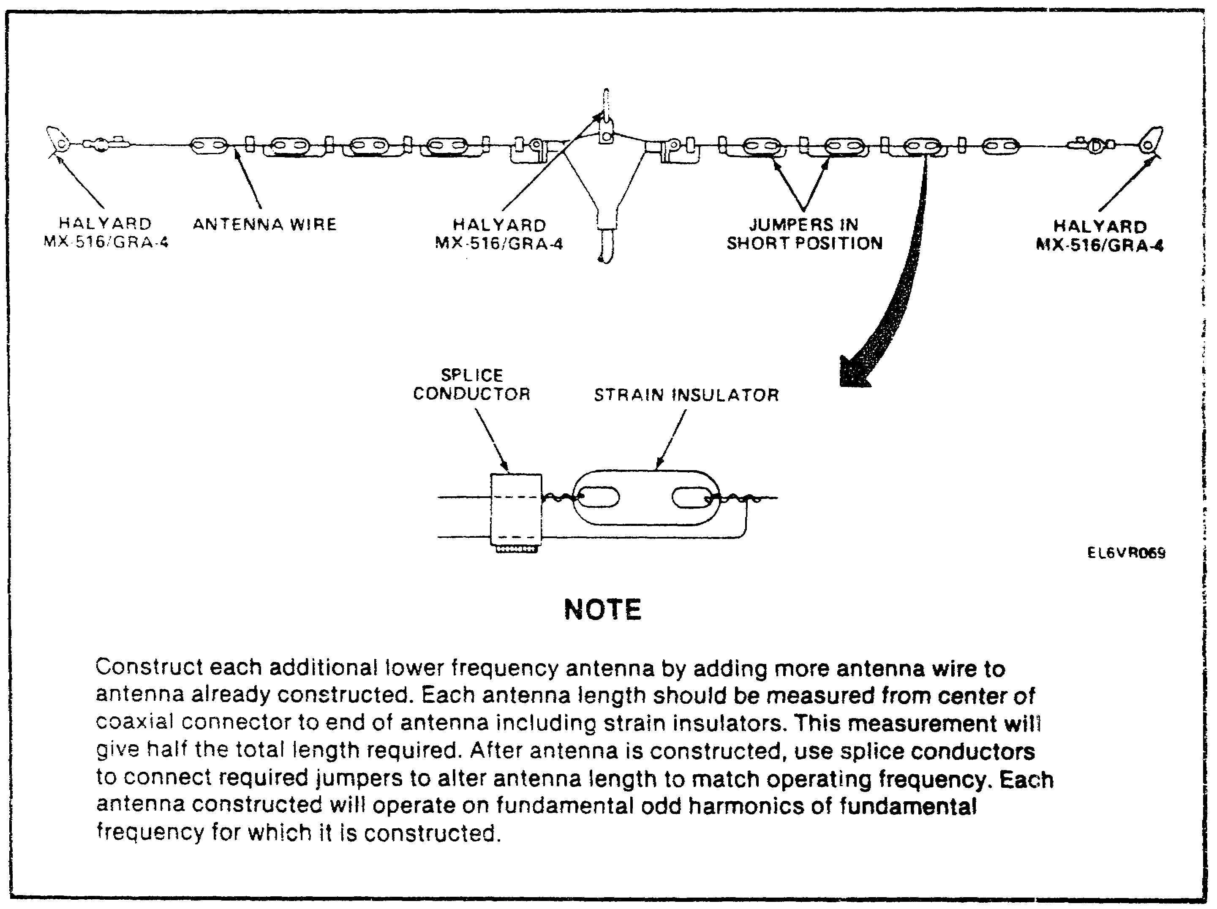

FIGURE 10. SEGMENTED WIRE DOUBLET.

22

Lesson 2/Learning Event 2

(3) Operation - Once the antenna has been properly constructed, you will want to operate on it. A good idea would be to label the jumpers on each side with the frequency that they will allow the antenna to operate at. Then, to set the antenna to operate on a given frequency, all you have to do is connect both jumpers for that frequency, make sure all jumpers between them and the CENTER insulator are connected and disconnect all others. See Figure 11. Notice that the jumpers at points A and B are connected and point C is not. This sets the antenna to operate on 2.750 MHz. Remember, Figure 11 shows only ONE side of the antenna. You will have to make your adjustments to BOTH sides for the antenna to work properly.

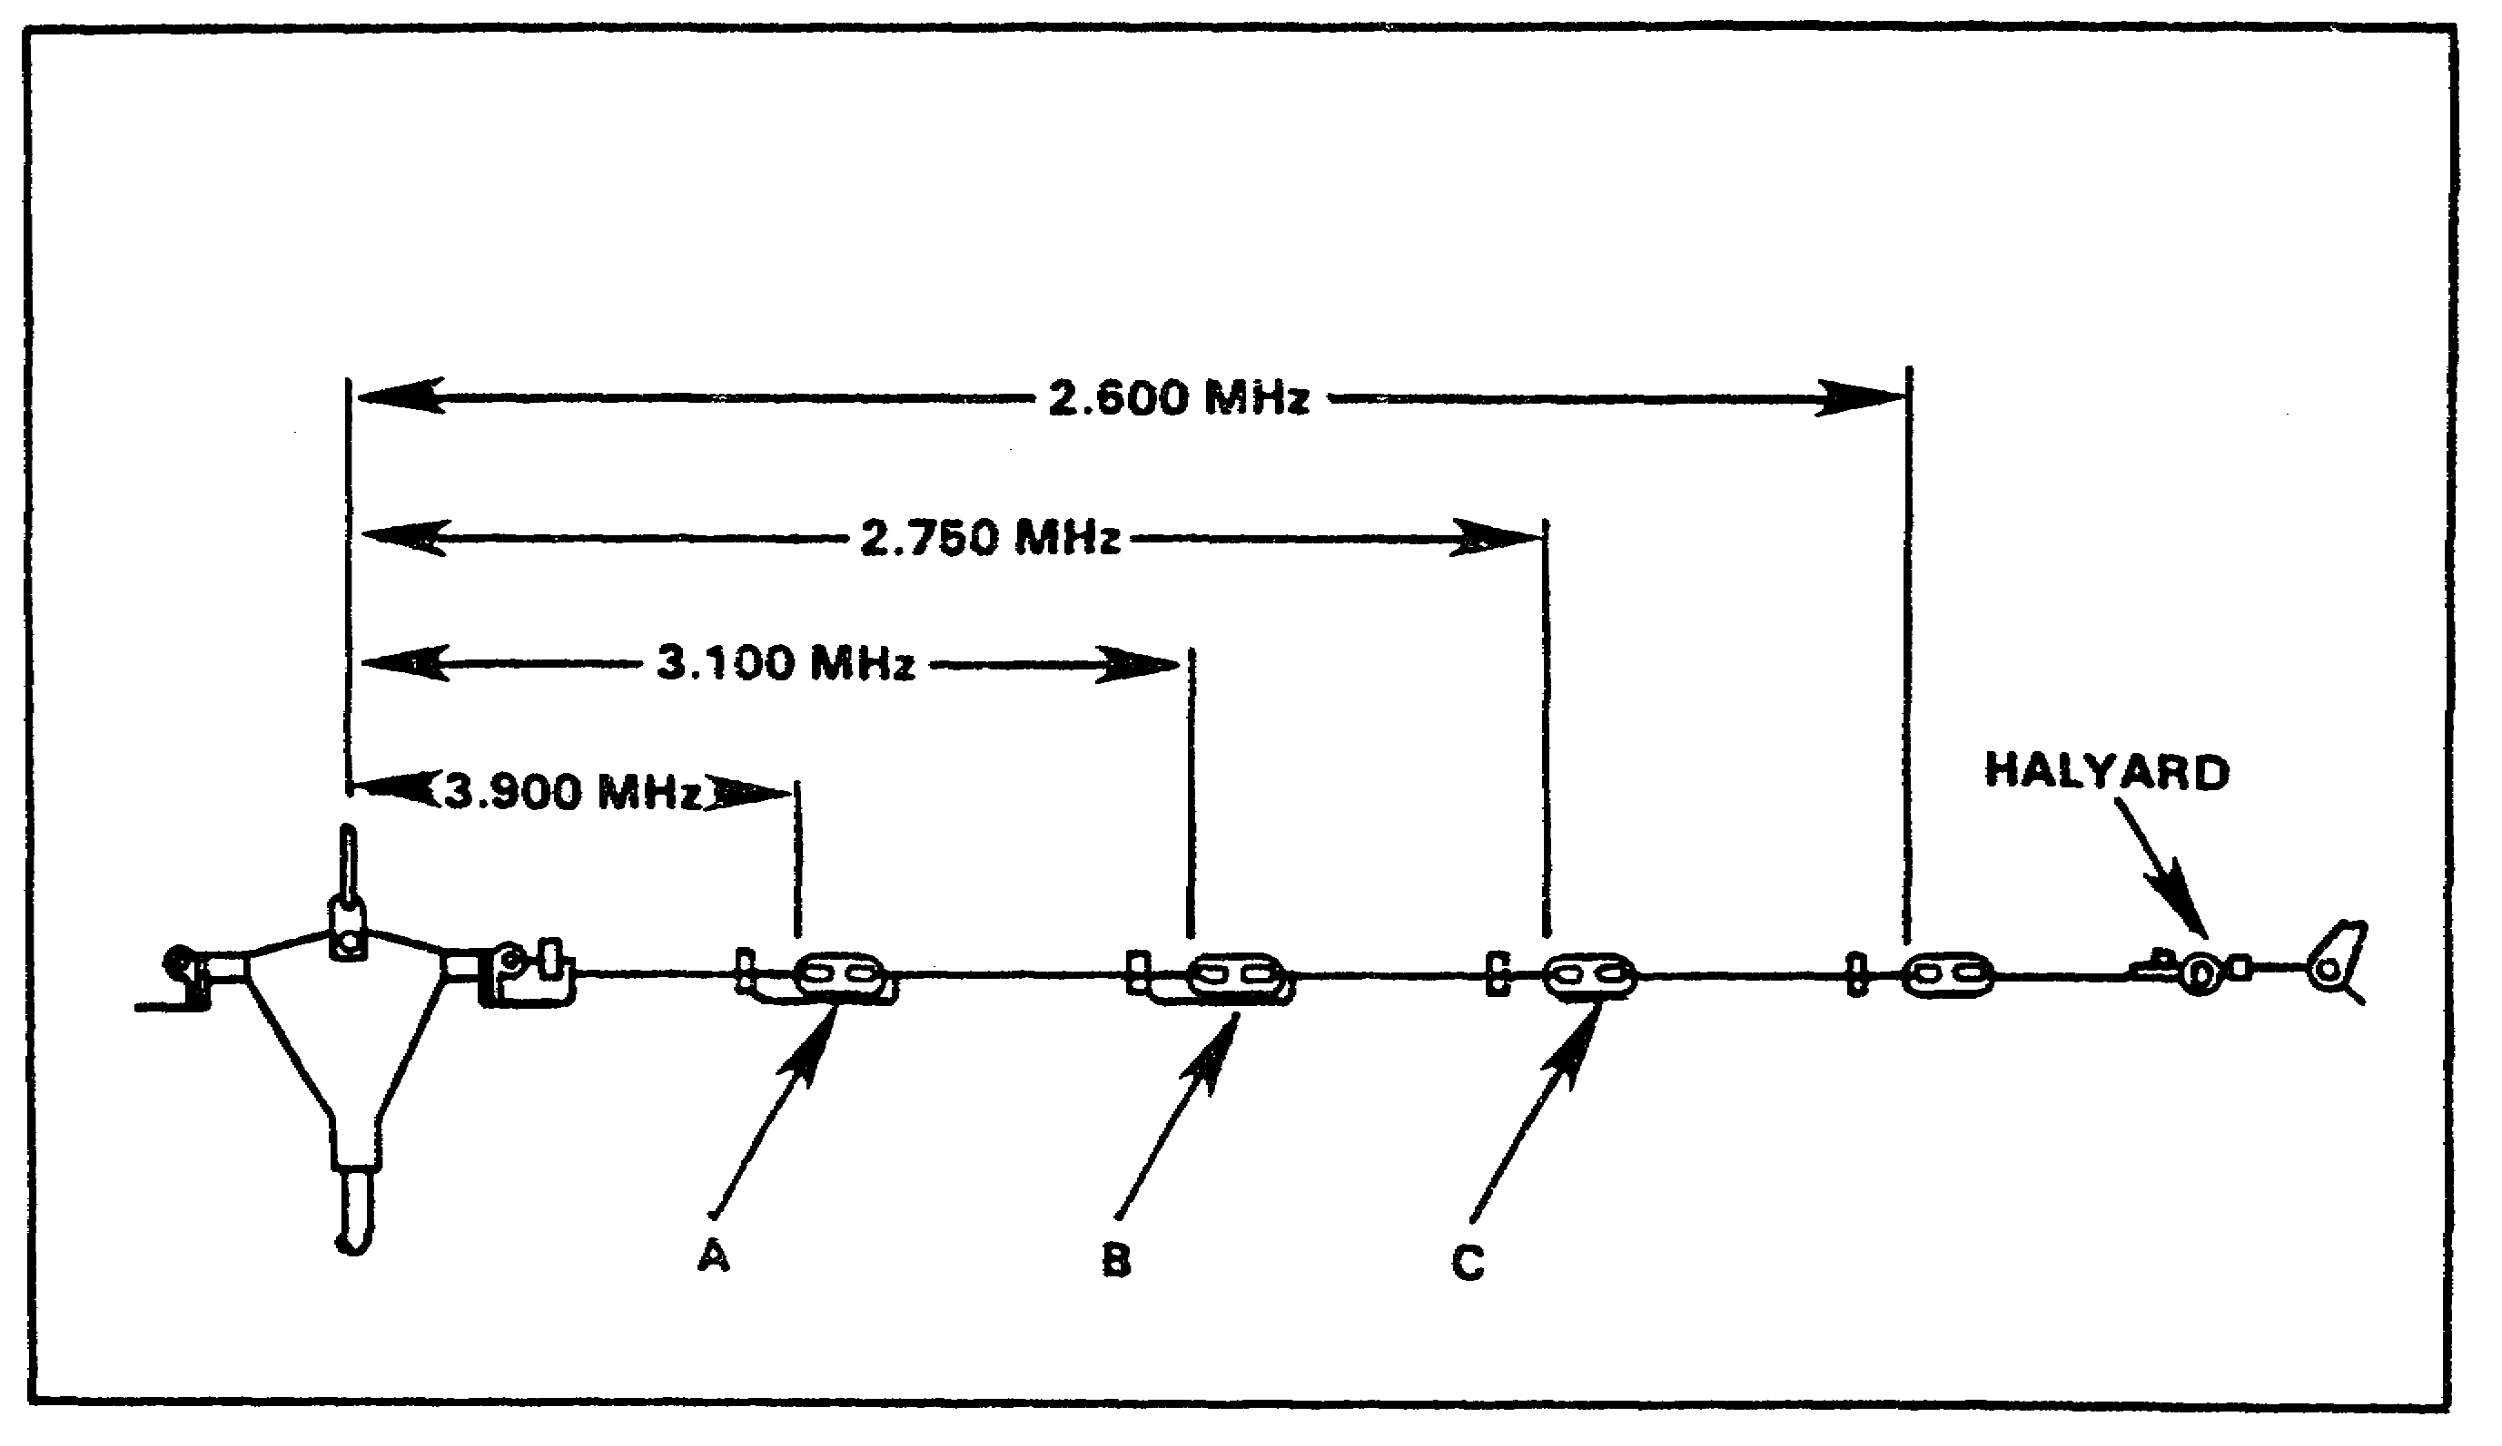

FIGURE 11. ONE SIDE OF SEGMENTED WIRE DOUBLET SET
FOR 2.750 MHZ.

3. AB-155/U ANTENNA MAST AND AB-1089 TRIPOD ADAPTER - These two pieces of equipment allow you to support your antenna in the air so you can communicate. For frequencies in the range of 2.0 to 4.0 MHz or if the antenna is over 120 feet long, three antenna supports are required.

a. Checks prior to deployment:

(1) Ensure that the mast sections are straight and that there is no dirt in the ends.

23

Lesson 2/Learning Event 2

(2) Check all guy ropes and the halyard to ensure that they are present and serviceable.

(3) Ensure that your guy stakes and AB-154/U swivel stake are present and serviceable.

(4) Check to ensure that all MX-379/U guy fasteners are present.

(5) Check to ensure that all MX-378/U guy rings are present.

b. Checks during installation of AB-155/U:

(1) Ensure that the guy stakes are 25 feet away from the AB-154/U swivel stake. This can be measured using five mast sections MS-44 assembled together.

(2) Ensure that the guy stakes are placed properly with respect to the antenna wire direction. See Figure 12.

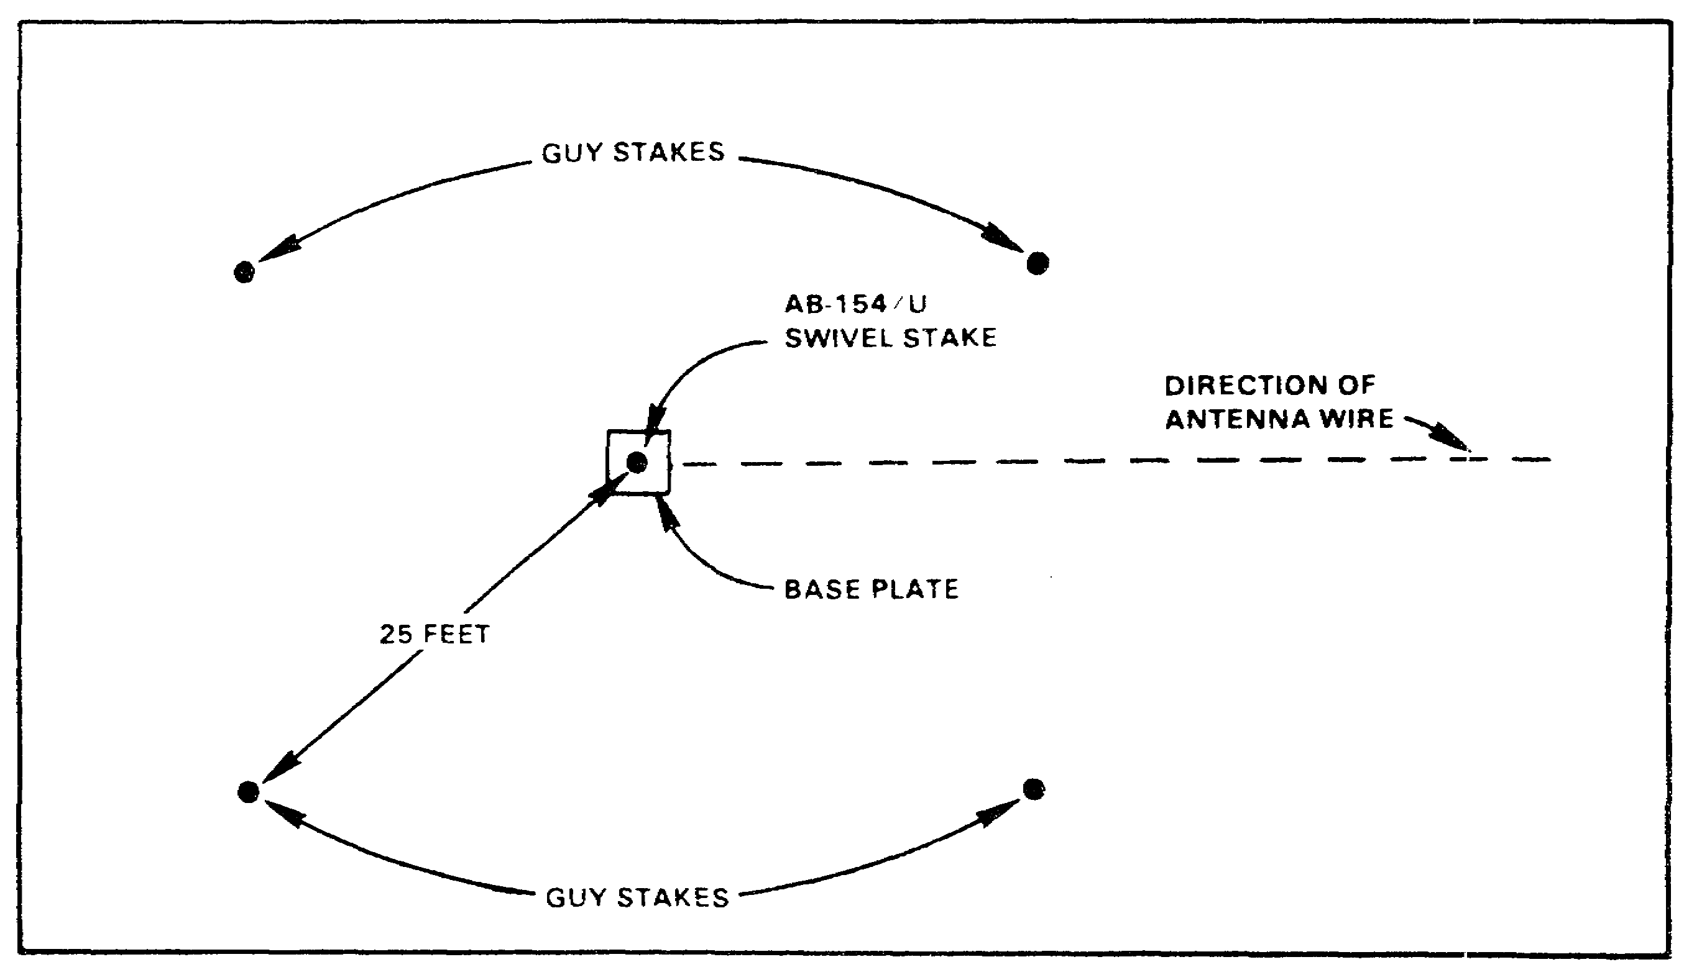

FIGURE 12. POSITIONS OF AB-155/U GUY STAKES.

(3) Ensure that MX-378/U guy plates are installed at the top of the third, fifth and eighth MS-44 mast sections and that the guy plates are turned to allow proper use of the halyard. See Figure 13.

(4) Ensure that halyard is attached to the top guy ring.

24

Lesson 2/Learning Event 2

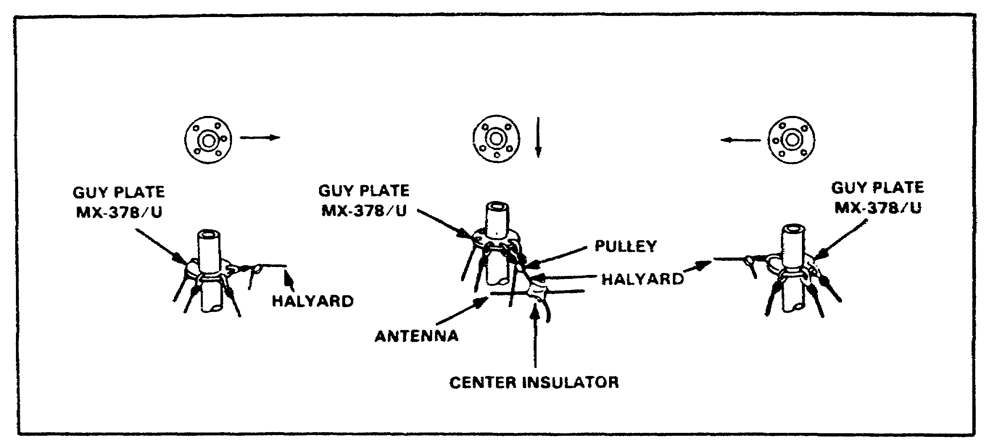

FIGURE 13. AB-155/U GUY RINGS.

(5) Once the antenna mast is erected, ensure that it is straight and vertical by directing the adjustment of the guy ropes.

(6) If you are using an antenna that requires three supports, ensure that the center support is offset 3 feet. See Figure 14.

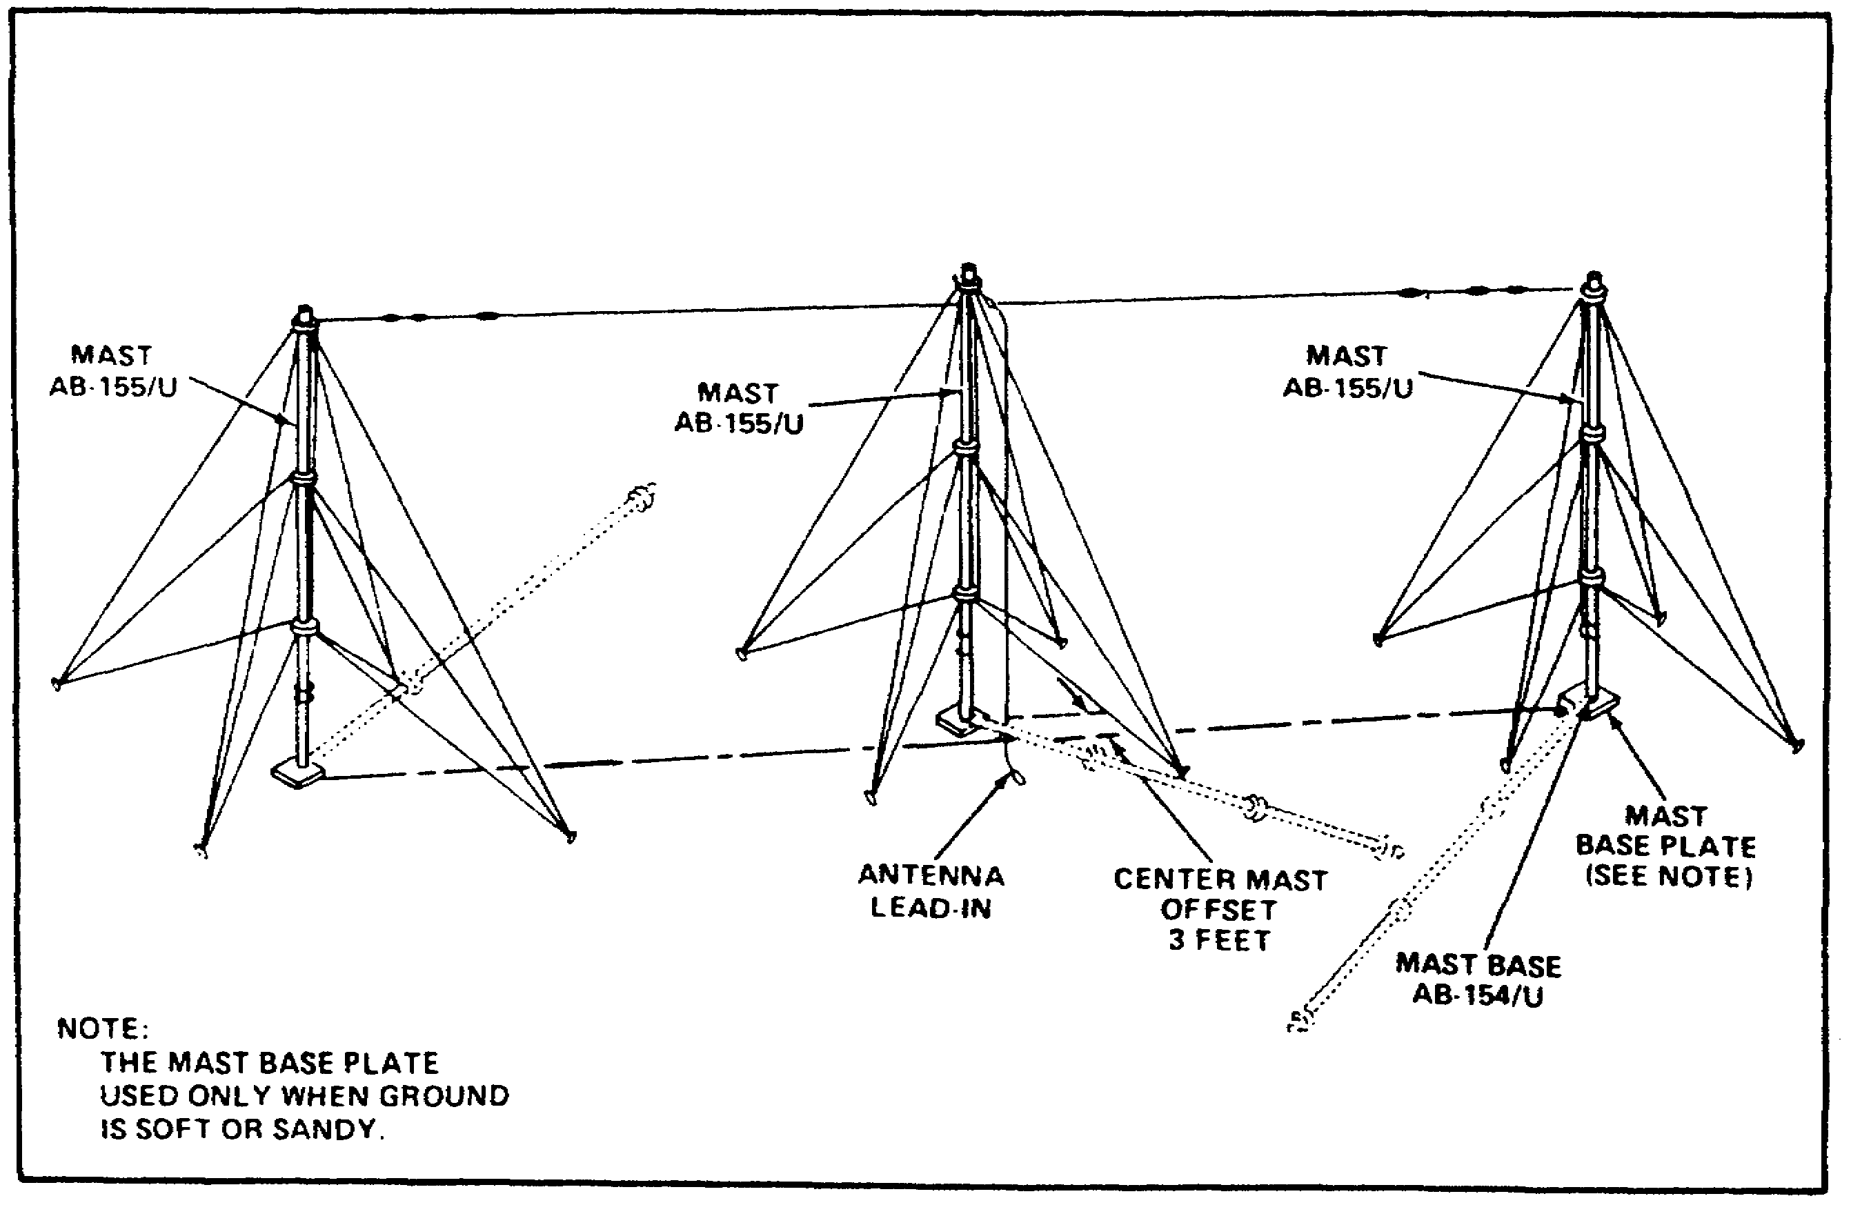

FIGURE 14. DOUBLET ANTENNA USING THREE AB-155/U MASTS.

25

Lesson 2/Learning Event 2

c. Checks during installation of AB-1089/U. The AB-1089/U tripod adaptor is designed to allow quick erection of supports for your doublet antenna. It can be used as either a guyed or unguyed support. It is used when you will need to erect and breakdown in a very short time. To ensure its proper use you should check the following:

(1) Ensure each leg is assembled from two MS-44 mast sections from your AB-155/U kit, and the vertical support is assembled from two MS-44 sections.

(2) Ensure that a guy plate MX-378/U is placed on the top MS-44 and that a halyard is attached to it.

(3) Erect the tripod ensuring that the legs are placed as in Figure 15.

(4) If you anticipate winds over 25 miles per hour, you must ensure that the mast is guyed. To measure the 15-foot distance from the center to each guy stake, use three MS-44s and place the guy stakes as shown in Figure 15.

(5) If you are using an antenna over 120 feet long, you must use three supports. Figure 15 illustrates where to place the center mast. As with the AB-155/U, offset the center mast by 3 feet.

26

Lesson 2/Learning Event 2

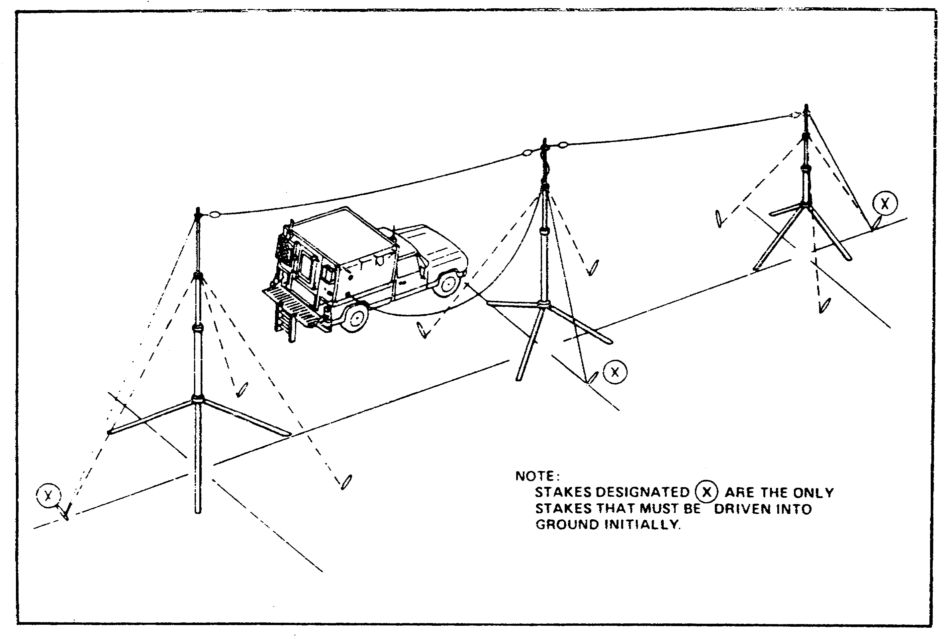

FIGURE 15. USE OF AB-1089/U TRIPOD ADAPTOR.

27

LESSON 2

LEARNING EVENT 2

PRACTICE EXERCISE

(PERFORMANCE-ORIENTED)

TASK: Direct the installation of common HF antennas.

CONDITIONS: Given an azimuth, information extracted from TM 11-5815-334-10 and FM 24-18, a pencil and paper and without supervision.

STANDARDS: Demonstrate competency of the task skills and knowledge by correctly responding to 70 percent of the multiple choice questions covering Directing the Installation of Common HF Antennas.

INSTRUCTIONS:

For each of the following questions, SELECT the one answer that BEST completes the statement or answers the question. Indicate your response by circling the correct letter below.

1. Using the formula:
Length = 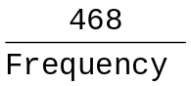

calculate the OVERALL length of a doublet antenna for a frequency of 9.570 MHz.

a. 42.3 feet.

b. 45.7 feet.

c. 48.9 feet.

d. 53.5 feet.

28

2. You are directing your team to install a doublet antenna that is 133.6 feet long. How many AB-155/U antenna masts will you direct them to install?

a. Two.

b. Three.

c. Four.

d. Five.

3. Which of the following doublet antennas is oriented properly to communicate with a station on an azimuth of 0°?


a.
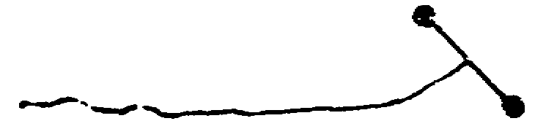

b.
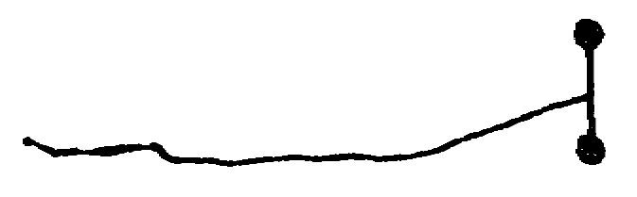

c.

d.

4. You are directing the installation of a segmented wire dipole antenna for all of the following frequencies. For which of the frequencies would you construct the antenna FIRST?

a. 3.455 MHz.

b. 4.685 MHz.

c. 6.365 MHz.

d. 8.295 MHz.

5. At the top of which AB-155/U mast sections would you direct your team to install the MX-378/U guy plates?

a. 2, 4, and 7.

b. 2, 5, and 8.

c. 3, 4, and 7.

d. 3, 5, and 8.

29

Lesson 3/Learning Event 1

LESSON 3

DIRECT CONSTRUCTION AND INSTALLATION OF FIELD
EXPEDIENT HF ANTENNAS

TASK

Direct the construction and installation of field expedient antennas.

CONDITIONS

Given an azimuth and information extracted from TM 11-5815-334-10, FM 24-18, and TC 24-19.

STANDARDS.

Demonstrate competency and knowledge by correctly answering 70 percent of the multiple choice questions on directing the construction and installation of field expedient antennas.

REFERENCES

FM 24-18, Chapter 3, Appendix M; TC 24-19, page 119;
TM 11-5815-334-10, pages D and E.

NOTE: Antennas are sometimes damaged or broken, causing either a communications failure or poor communications. If a spare is available, there is no problem-simply replace the damaged antenna. When spares are not available, then you must use field expedient materials and techniques to repair or construct your antenna.

Learning Event 1:
IDENTIFY FIELD EXPEDIENT ANTENNA MATERIALS.

1. Repairing existing antennas is usually easier than constructing a new antenna. If it is not possible to repair your antenna using conventional materials or techniques, then you must use field expedient materials or techniques. There are two types of materials used in the repair and construction of antennas.
They are:

a. INSULATORS - These prevent the flow of electrical energy. They are listed in order from best to worst. See Figure 16.

(1) Glass.
(2) Plastic.
(3) Rubber.

30
Lesson 3/Learning Event 1

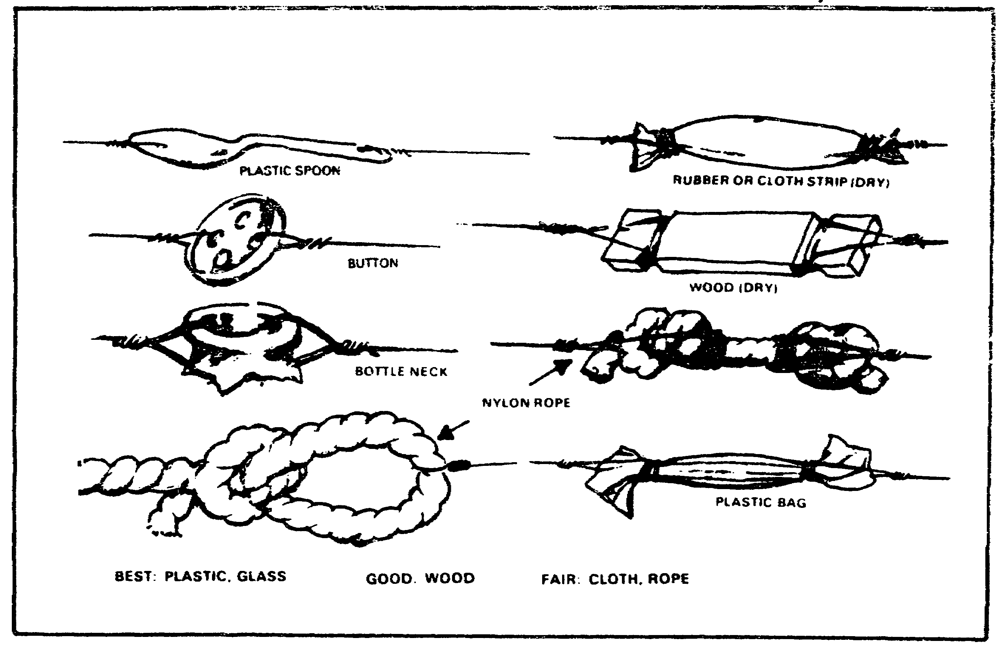
FIGURE 16. FIELD EXPEDIENT INSULATORS.

(4) Wood.
(5) Rope.
(6) Cloth.

b. CONDUCTORS - These allow the flow of electrical energy. They are listed in order from best to worst.

(1) Copper wire, such as W-1 antenna wire or abandoned telephone or electrical wire.

(2) Aluminum wire

(3) WD-1 telephone wire

(4) In an EMERGENCY - Use any wire that is available, such as concertina wire, barbed wire, fence wire, etc.

2. RADIATING ELEMENTS. The radiating element is the heart of the antenna. If it is damaged or not constructed properly, damage to the radio can occur, communications can be degraded and you may fail to accomplish your communications mission. If it becomes necessary to apply field expedient means to repair the radiating element of your antenna you must ensure that the radiating element is measured to the correct length. Use the best conductor (wire)

31

Lesson 3/Learning Event 1

that you can find and ensure that all connections are strong mechanically and solid electrically.

a. Whip antennas are the most difficult to repair.

(1) Materials you must have on hand:

(a) Splint material - this can be almost anything that is stiff enough to strengthen the broken area. It will need to be strong but light in weight. Small tree limbs, short pieces of wood stripping and similar materials work well.

(b) Bare wire to secure the splint to the antenna and to ensure a good electrical connection. W-1 antenna wire works best.

(c) Something to scrape the paint off of the antenna element.

(d) Tape (optional) - This will protect the splint you make.

(2) The repair steps are:

(a) Scrape off all the paint from the antenna element for about 6 inches on either side of the break.

(b) Lay the two pieces of the antenna element side-by-side with the broken ends overlapping each other. See Figure 17.

(c) Wrap the wire tightly around the two broken ends all along the area where there is no paint.

(d) If you have tape, wrap it around the repair.

(e) Lay the splint material alongside the break. The splint material should be about 18 to 24 inches long.

(f) Use more of the wire to bind the splint tightly to the antenna element.

b. Wire antennas, such as the doublet, are very easy to repair. All you have to do is tie the two broken ends together with a square knot, then make sure that enough wire is added to the antenna to bring it back to the proper length for the frequency you are operating on.

32

Lesson 3/Learning Event 1

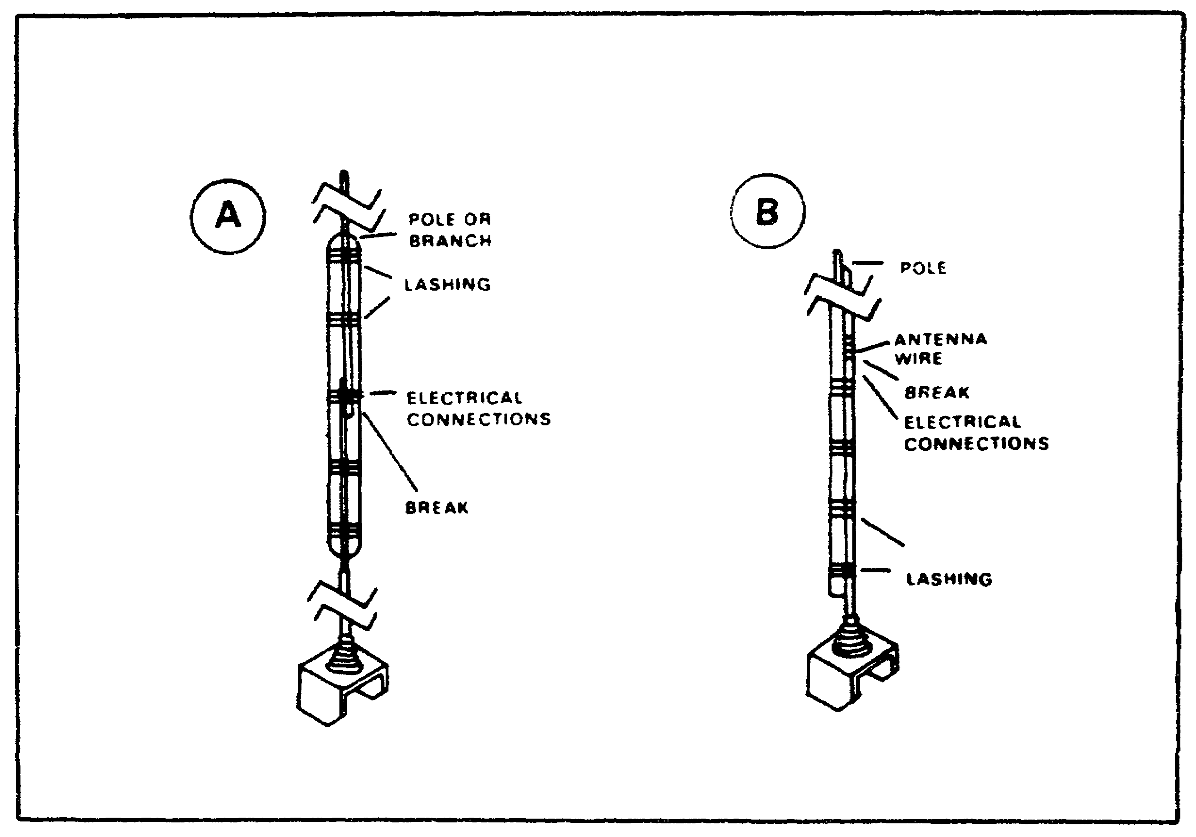
FIGURE 17. FIELD EXPEDIENT REPAIR OF WHIP ANTENNAS.

3. ANTENNA LEAD-IN - For the antenna to radiate RF energy, the energy has to first be applied to the antenna. That is the purpose of the antenna lead-in. It carries RF energy from the transmitter to the antenna, and from the antenna to the receiver. If it becomes broken or damaged, it cannot do its job properly. Of course, if you have a replacement lead-in you don't have a problem, just install the replacement. When you DON'T have a replacement lead-in, then you must use field expedient techniques to repair or replace it.

NOTE: Use these techniques ONLY in an emergency or if you must communicate and there is NO other way to do so.

CAUTION

BEFORE ATTEMPTING THESE REPAIRS, ALWAYS ENSURE THAT YOUR RADIO TRANSMITTER IS TURNED OFF OR TO STANDBY. ALSO ENSURE THAT YOUR COAX CABLE OR OTHER LEAD-IN IS DISCONNECTED. THIS WILL PREVENT RADIO FREQUENCY BURNS AND OTHER RF INJURIES.

Repair –

- The most common type of lead-in you will encounter is the RF coaxial (coax) cable, and the most common problem you will encounter is RF connectors that get pulled off of the cable. If this happens to you, do NOT just push the connector back on the cable and reuse it. This could result in damage to equipment or injury to personnel. Instead, assuming that the coax cable itself is good, it can be reused even though one or both of the connectors have been pulled off.

(b) From the other end of the coax cable remove about 6 inches of the outer insulation exposing the braided shield.

(c) Unbraid the braided shield and twist the braid wires together.

(d) Cut the inner insulation and center conductor to a length of about 2 inches.

(e) Remove about 1/2 inch of the inner insulation, exposing the center conductor.

(f) Twist the wires of the inner conductor together.

(g) Refer to Figure 20. Carefully insert the center conduction of your cable into the center pin of the doublet antenna connector on the side of your shelter.

(h) Wrap the braid of your coax cable around the outside of the coaxial connector and secure it with tape, a piece of copper wire, a small hose clamp or anything else that will keep the braid securely in place.

(i) Ensure that the center conductor and braid do not touch.

(j) Tie off the cable so no strain will be placed on the connection you have made.

b. REPLACEMENT - If your coax cable has been lost, destroyed or too badly damaged to be re-used, you must come up with an alternate or emergency transmission line (lead-in).

(1) If this happens, you must ensure that the wire you select as your emergency lead-in meets the following requirements:

- It must be a twisted pair. This prevents it from becoming part of the radiating element.

- It must be insulated.

- It must be as short as possible. This is an inefficient transmission line and suffers a lot of signal loss.

- It must be connected properly to the antenna and the radio.

Lesson 3/Learning Event 1

(1) ONE CONNECTOR MISSING - If only one connector is missing, the repair is simple. To ensure a good connection at the radio, connect the end of the cable that still has a connector to the antenna connector on the side of your RATT set (or radio). To prepare the other end of the cable for use, perform the steps below. Refer to Figure 18.

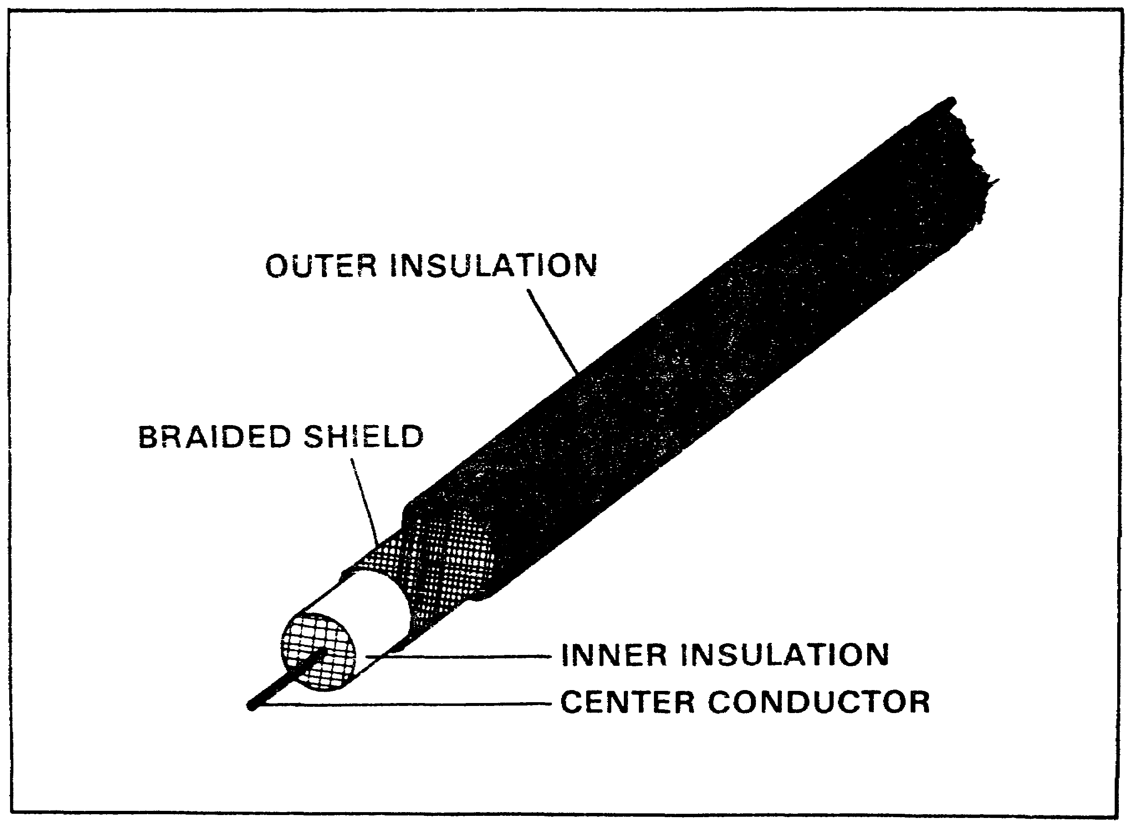

FIGURE 18. COAXIAL CABLE.

(a) Remove about 4 inches of the outer insulation from the end of the cable that has NO connector, exposing the braided shield.

(b) Carefully unbraid the shield and pull the braid wires away from the inner insulation.

35

Lesson 3/Learning Event 1

(c) Twist the braid wires together.

(d) Remove about 2 inches of the inner insulation, exposing the center conductor.

(e) Refer to Figure 19. Connect the center conductor to one of the terminals of your IL-4/GRA-4, and tighten the wing nut down.

(f) Connect the braided wire to the other terminal of your IL-4/GRA-4, again tightening the wing nut.

(g) Ensure that you place a strain relief on the cable as shown. The strain relief is described in Lesson 2.

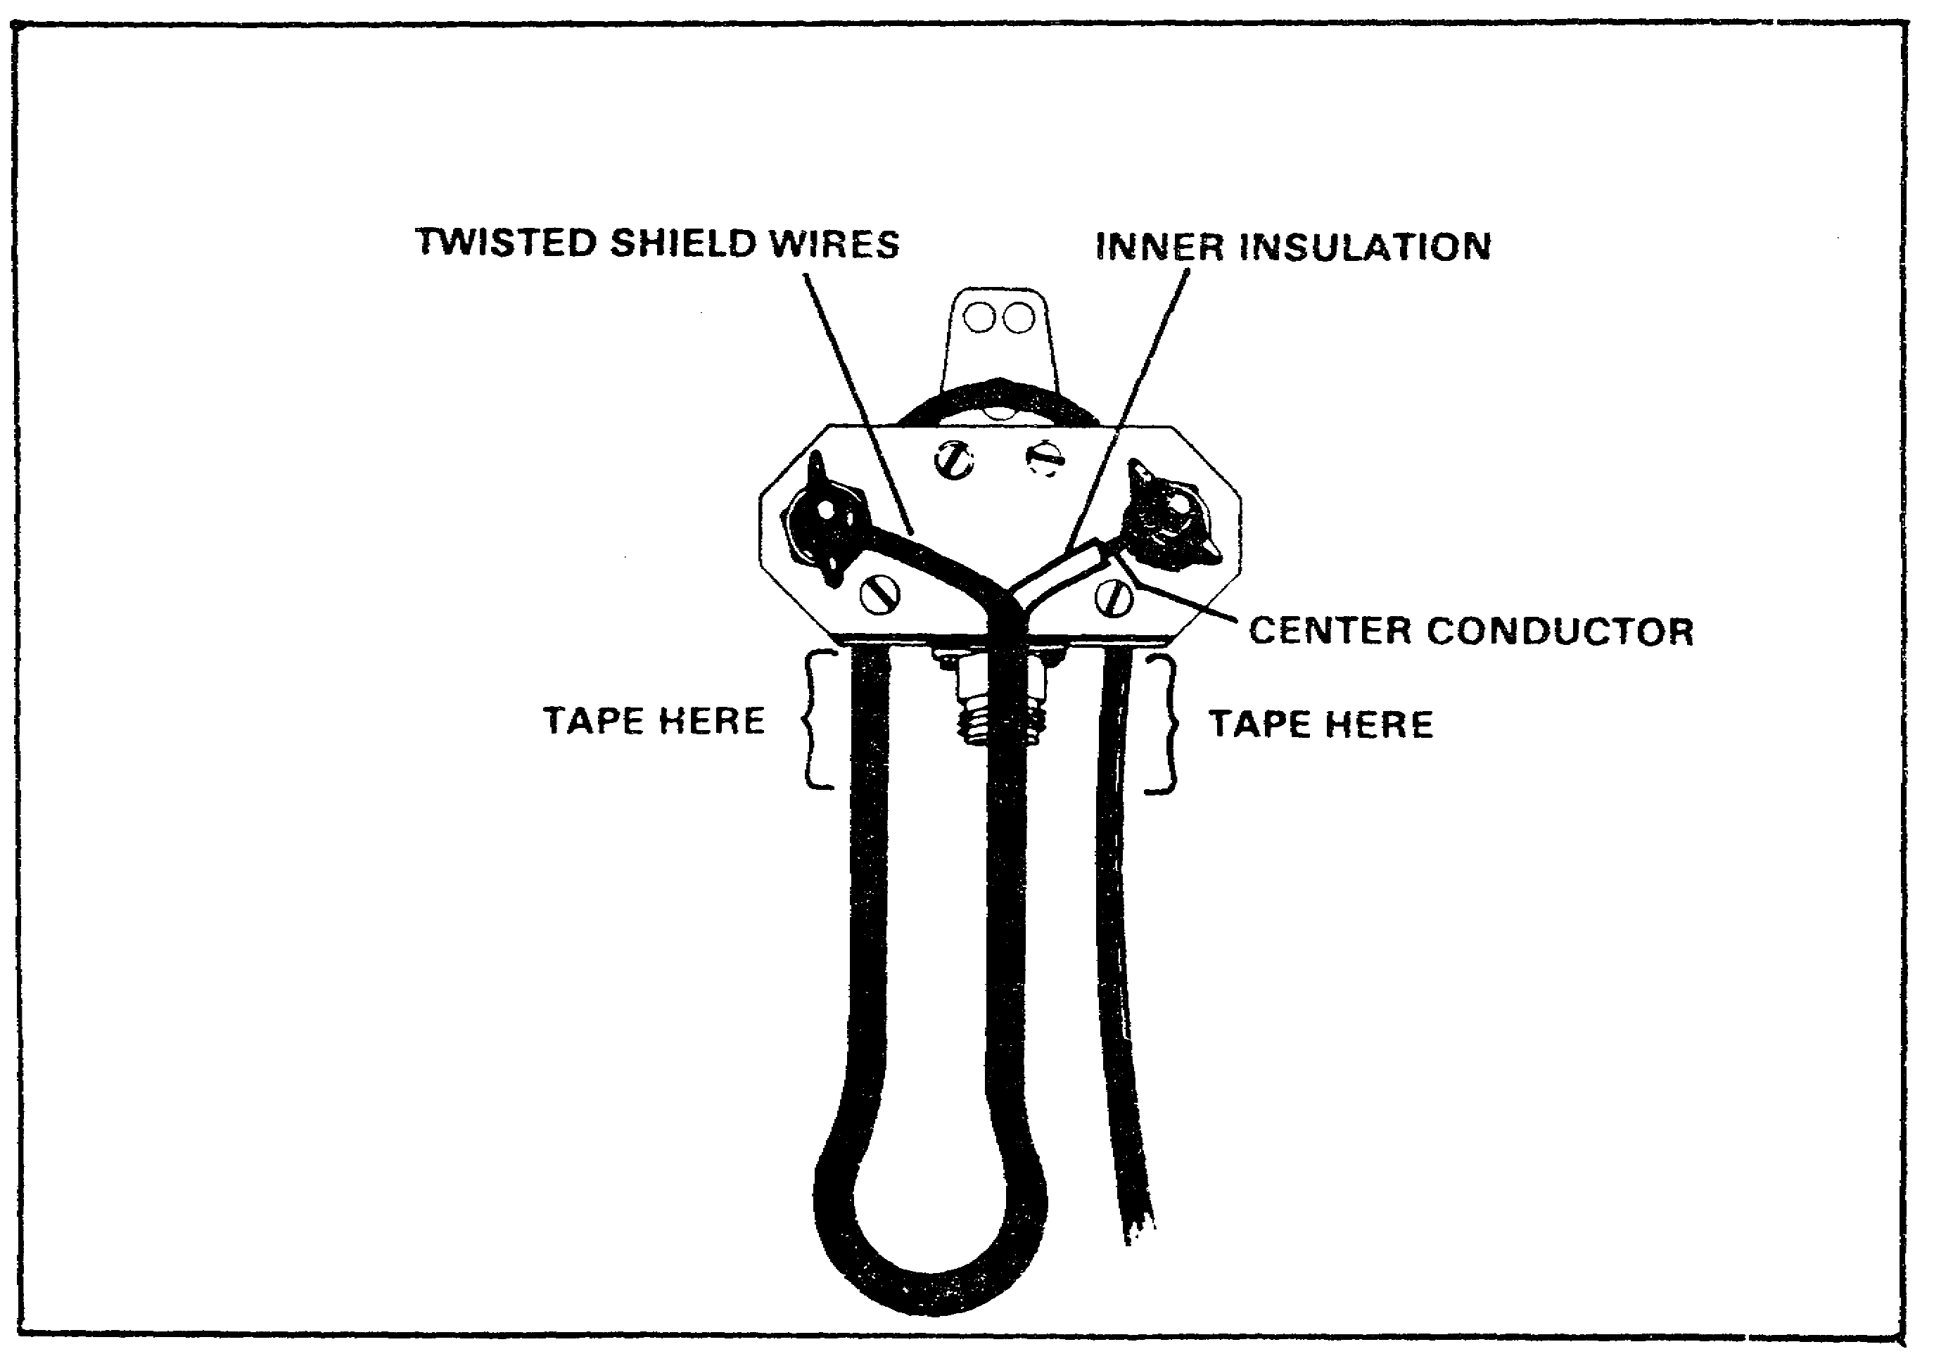
FIGURE 19. FIELD EXPEDIENT CONNECTION OF COAXIAL
CABLE TO IL-4/GRA-4.

(2) BOTH CONNECTORS MISSING - When both connectors are missing, the repair is somewhat more difficult. To make this repair, perform the following steps:

(a) Connect one end of your cable to the IL-4/GRA-4 as described above.

36

Lesson 3/Learning Event 1

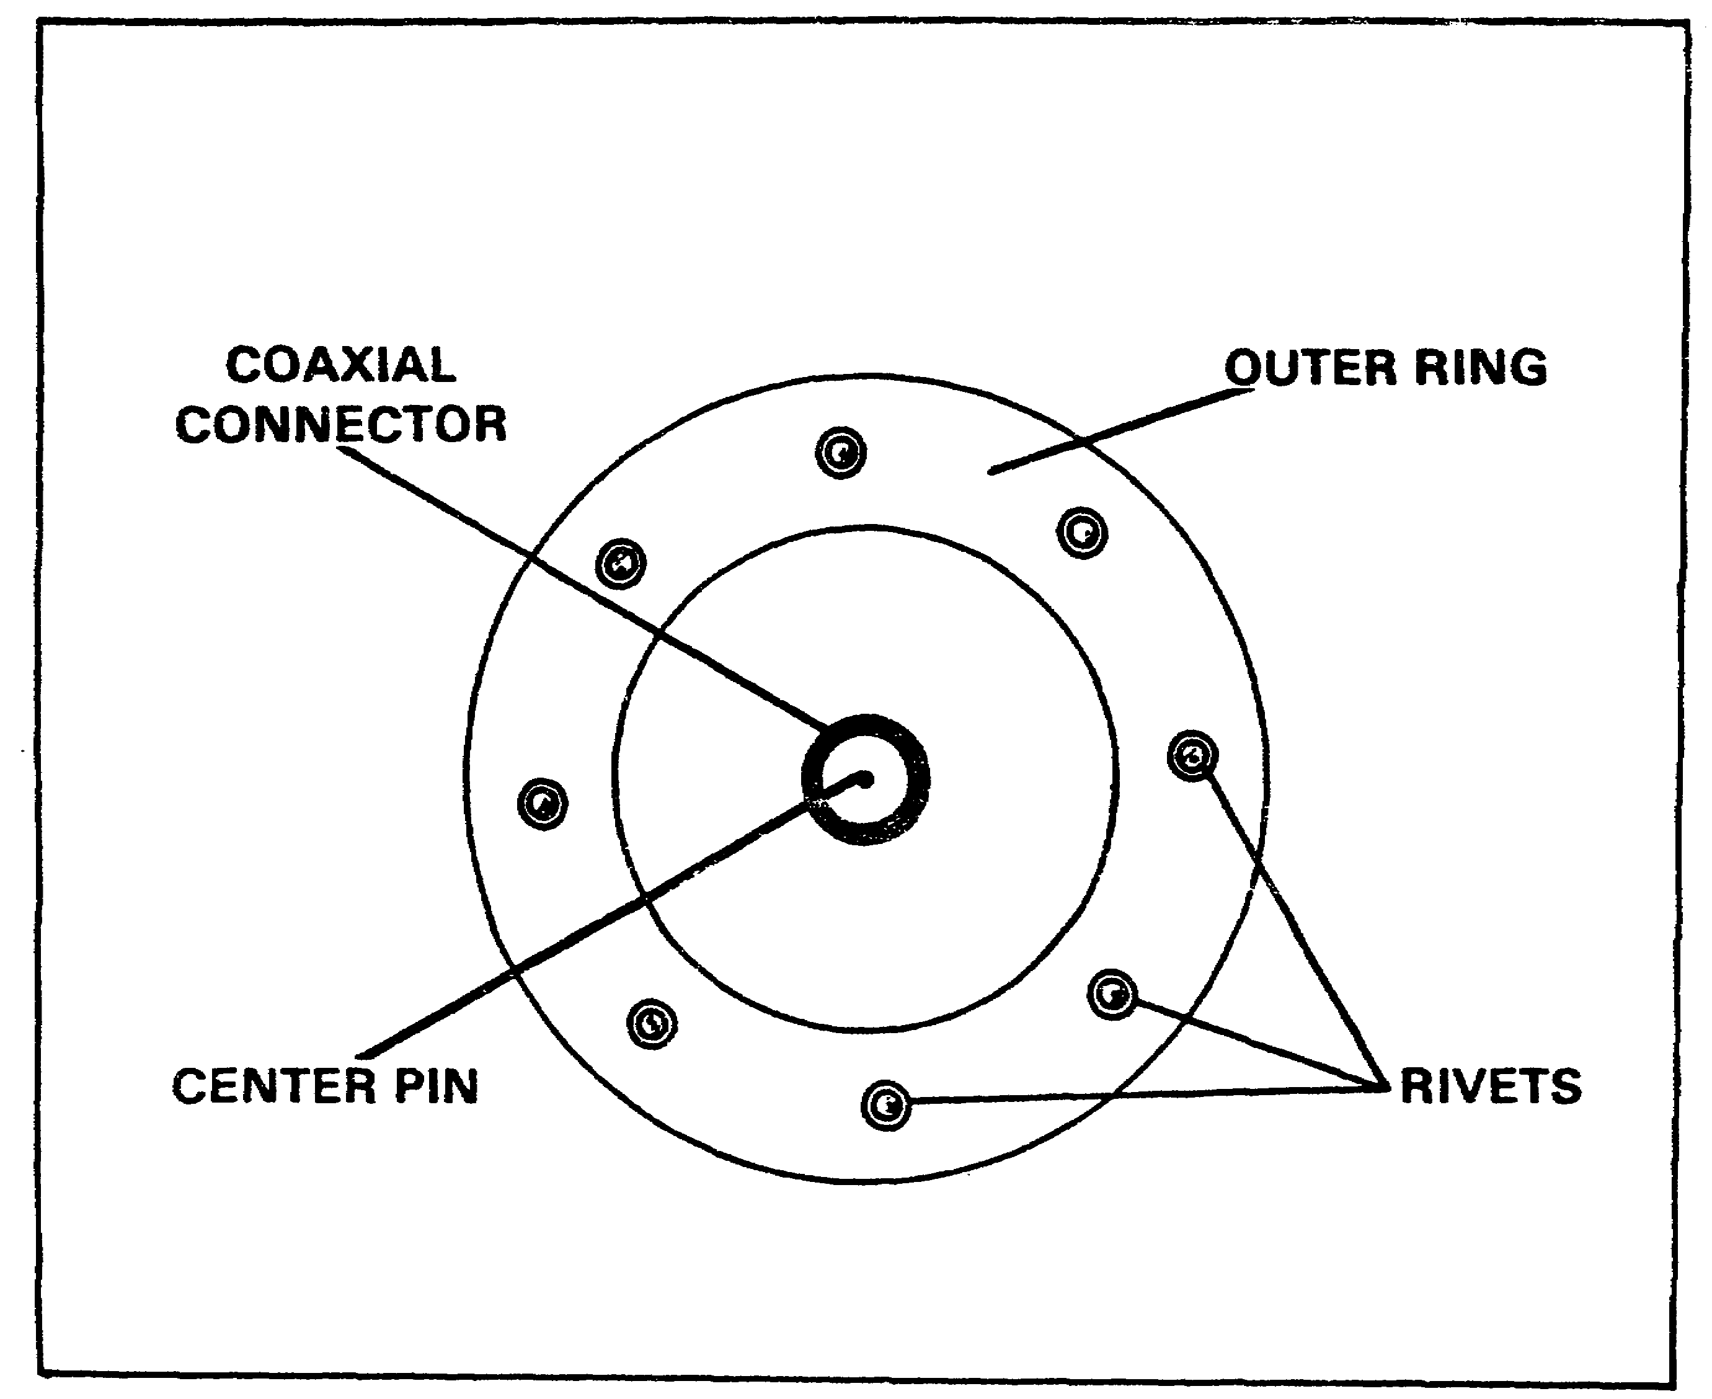

FIGURE 20. COAXIAL CABLE CONNECTOR ON AN/GRC-122
OR AZ/GRC-142.

(2) WD-1/TT telephone wire is very plentiful, and meets all of these requirements. To connect your emergency transmission line, follow the same procedures as for the coax cable. On one end, attach one wire to each of the connectors on your IL-4/GRA-4 and on the other end attach the wires to the doublet antenna connector on your shelter in the same manner as for the coax cable. However, it will be easier to secure the one wire to the outside of the coax connector if you first remove the steel strands from that wire. Again, you must ensure that no strain is placed on the connection and that the wires will not come into contact with each other.

37

Lesson 3/Learning Event 1

4. INSULATORS - It may become necessary for you to replace one or more of the insulators in your antenna with field expedient insulators. If this should happen, use the best field expedient insulator you have available. You must make sure that the field expedient insulator you use has enough mechanical strength to withstand any strain it may be placed under. Use glass if it is available. Bottles, old power line insulators and so on are the best. If you know the weather is going to be wet or that your antenna will become wet, DO NOT use wood, rope or cloth as insulators. When they become wet they become conductors.

5. SUPPORTS AND GUYS - You must keep your antenna up in the air. That is the purpose of supports and guys. Some of the materials that you can use are:

a. Supports.

(1) Trees.

(2) Buildings.

(3) Vehicles - Make sure that they will not move.

(4) Poles.

CAUTION

DO NOT USE POWER POLES THAT HAVE LIVE POWER LINES ON THEM. YOU COULD BE INJURED OR KILLED.

(5) Supports you build yourself such as A-frames.

b. Guys - If you are using rope guys, you may be able to repair a broken one by just tying the broken ends back together. If you cannot, then these are some of the field expedient ways to replace or repair them:

(1) Any rope.

(2) Any kind of wire - But you MUST make sure that it is insulated from the antenna wire. You also should cut the wire you use for a guy into short pieces (about 3 to 6 feet long) and hook them together with insulators. This will prevent your guy wire from having any effect on the performance of the antenna.

(3) Pieces of cloth tied together.

38

LESSON 3

LEARNING EVENT 1

PRACTICE EXERCISE

(PERFORMANCE-ORIENTED)

TASK: Identify field expedient antenna materials.

CONDITIONS: Given information extracted from TM 11-5815-334-10, FM 24-18 and TC 24-19, a pencil and without supervision.

STANDARDS: Demonstrate competency and knowledge by correctly answering 70 percent of the multiple choice questions covering identifying field expedient antenna materials.

INSTRUCTIONS:

For each of the following questions, SELECT the one answer that BEST completes the statement or answers the question. Indicate your response by circling the correct letter below.

1. Which of the following is the best field expedient antenna wire?

a. Copper electrical wire.

b. Steel fence wire.

c. Concertina wire.

2. You are directing the installation of an antenna using field expedient insulators, and you know that it is going to rain. Which of the following materials would you NOT use?

a. A glass bottle.

b. A plastic bag.

c. A piece of an old towel.

d. A piece of inner tube.

39

3. Which of the following would you NOT use as a field expedient support for your doublet antenna?

a. Trees.

b. Buildings.

c. Power lines.

d. Vehicles.

4. Your RF coax cable has been lost and you must install an emergency lead-in from your antenna to your radio. Which of the following is one of the requirements for this emergency lead-in?

a. Must be at least 1/2 wavelength long.

b. Must be a single wire.

c. Must be insulated.

d. Must be connected to the ground rod.

40

Lesson 3/Learning Event 2

Learning Event 2:
IDENTIFY TYPES OF FIELD EXPEDIENT ANTENNAS.

Before you can direct the installation of field expedient antennas, you have to know how they work and what type of situation to use them for.

1. WHIPS - Whips are vertically polarized, omnidirectional, ground wave antennas. They are best employed for short distance communications or while on the move.

2. COUNTERPOISE - A counterpoise is used to enhance an already existing antenna by providing an artificial ground surface. A counterpoise is best employed when the natural ground surface is too dry or rocky to provide a good ground for the antenna.

3. INVERTED V - An inverted V antenna is really just a doublet that only has one support. This support is placed in the center, giving the antenna the appearance of an upside down letter "V". The main advantage of the inverted V antenna is that it only requires one support and is much faster to erect than an antenna that requires more than one support. It is a good compromise for tactical communications systems. It is slightly more directional than a doublet. However, if you install an inverted V antenna within 1/4 wavelength of the ground in order to take advantage of Near Vertical Incidence Skywave (NVIS) radiation, the inverted V is essentially omnidirectional.

4. NEAR VERTICAL INCIDENCE SKYWAVE (NVIS) - This is not so much an antenna as it is a concept that can be applied to existing antennas to increase their reliability out to a distance of about 480 kilometers (300 miles).

a. Under ideal conditions, the ground wave component of a radio wave becomes unusable at a distance of about 80 kilometers (50 miles). Under the conditions you will encounter out in the field, the distance will be much less, sometimes as little as 3 kilometers (2 miles). The skywave component generated by antennas that launch it efficiently, such as the doublet, will not return to earth at less than 160 kilometers (100 miles). This will leave an area where HF communications will not function. This area is commonly called the "Skip Zone", and it can be from 80 to 113 kilometers (50 to 70 miles) long.

b. Radio energy that is radiated in a near vertical incidence direction, that is, straight up, is not reflected back to a pinpoint on the Earth's surface. Radio waves of too high a frequency will penetrate the ionosphere and escape into space. Radio waves of a low enough frequency will be reflected back at all angles (including the zenith) resulting in omnidirectional coverage with no dead spots (that is, without a skip zone). The effect is similar to taking a water hose with a fog nozzle and

41

Lesson 3/Learning Event 2

pointing it straight up into the air. The water falling back to earth covers a circular area out to a given distance. This is the main advantage of using the NVIS principle; it eliminates the skip zone.

c. This radiation pattern will allow you to communicate effectively out to a distance of about 480 kilometers (300 miles). NVIS minimizes the effects of terrain and vegetation allowing you to set up your antenna just about anywhere, not just high ground. This means that you and your operators can operate from protected, dug-in positions. If you are using an antenna that radiates a strong ground wave as well as NVIS radiation, there may be some interference between the two. By properly selecting your site and antenna you can minimize it.

d. Jamming and radio-direction-finding (RDF) are more difficult for the enemy to accomplish. NVIS radiation returns to Earth from the sky in all directions, thus making it more difficult to RDF. By taking advantage of terrain features to block jamming signals, you can reduce the effect of ground wave jamming signals.

e. Use NVIS in the following situations:

(1) Your area of operation is not conducive to ground wave communications (for example, in the mountains).

(2) Tactical deployment places stations in the skip zone when using traditional operating methods.

(3) When operating in heavy, wet jungle (or other areas of high signal absorption).

(4) When prominent terrain features (high ground) are not under friendly control.

(5) When operating against enemy ground wave jammers and radio direction finders.

5. LONG WIRE - The long wire antenna can be used to extend the ground wave range of your radio. It is best used when you are at a halt, and there is only one station that you wish to talk to. The long wire antenna is the most directional antenna that will be discussed here. It is vertically polarized. If it is terminated with a 500 to 600 ohm resister, it concentrates all of the radio energy in just one direction, away from the radio, in the general direction of the wire. If it is NOT terminated, then it becomes a bidirectional antenna, radiating in two directions along the wire. This is a large antenna. The minimum length is one wavelength, and at lower HF frequencies this can be a very long piece of wire.

42

Lesson 3/Learning Event 2

6. FAN DIPOLE - This is a multiple frequency antenna. It allows your antenna to be operated on several different frequencies without the need for adjustment every time you change from one of the frequencies to another. It takes longer to set up and adjust when it is first installed, and it requires more material, but it makes up for it through its ease of use. All you have to do is change the frequency on your radio and retune the amplifier. This antenna is most suitable if you will not be changing your location frequently.

43

LESSON 3

LEARNING EVENT 2

PRACTICE EXERCISE

(PERFORMANCE-ORIENTED)

TASK: Identify the types of field expedient antennas.

CONDITIONS: Given information extracted from TM II-5815-334-10, FM 24-18 and TC 24-19, a pencil and paper and without supervision.

STANDARDS: Demonstrate competency of the task skills and knowledge by correctly responding to 70 percent of the multiple choice questions covering identification of the types of field expedient antennas.

INSTRUCTIONS:

For each of the following questions, SELECT the one answer that BEST completes the statement or answers the question. Indicate your response by circling the correct letter below.

1. Which of the following antennas has the MOST directional radiation pattern?

a. Long wire.

b. Inverted V.

c. Dipole.

d. NVIS.

2. What is the main advantage the inverted V antenna has over the doublet?

a. More gain.

b. Longer range.

c. Easier to construct.

d. Unidirectional.

44

3. What is the main advantage of an antenna that is designed to use the NVIS principle?

a. Increases the ground wave range.

b. Eliminates the skip zone.

c. More directional radiation pattern.

d. Low angle of radiation.

45

Lesson 3/Learning Event 3

Learning Event 3:
DIRECT INSTALLATION OF FIELD EXPEDIENT ANTENNAS.

1. WHIPS - Whips are the easiest antennas to replace or enhance.

a. Replacement - Cut a piece of wire that is a little longer than your whip antenna. Attach one end to the antenna connector on your radio and hang the other end from an overhead support using a piece of rope or other insulating material. Ensure you keep the antenna as vertical as possible. See Figures 21 and 22.

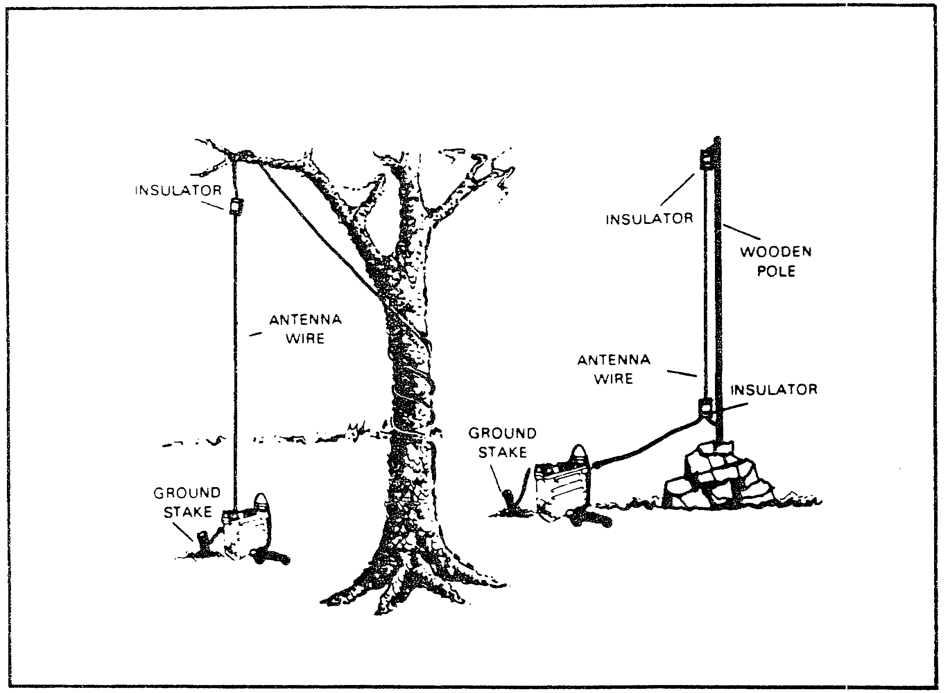

FIGURE 21. FIELD EXPEDIENT WHIP REPLACEMENT.

46

Lesson 3/Learning Event 3

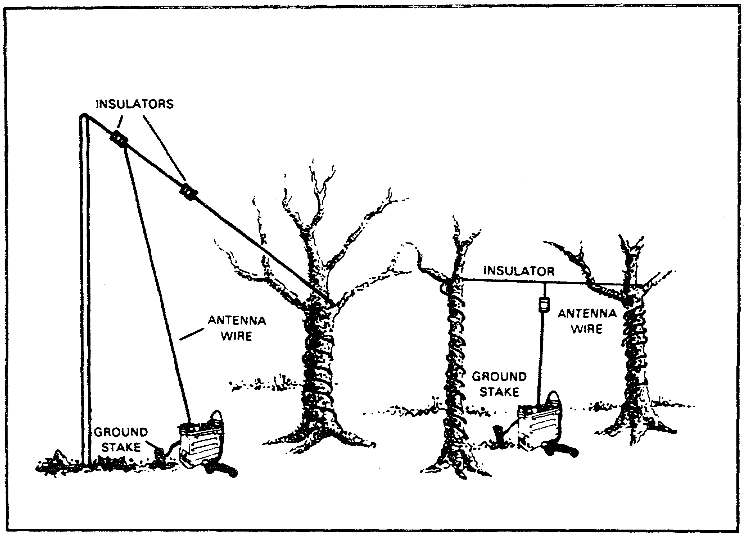

FIGURE 22. FIELD EXPEDIENT WHIP SUPPORTS.

b. Enhancement - Whip antennas can be enhanced several ways.

(1) Lengthening the whip will make it act more like the quarter wave antenna it is supposed to be. You can lengthen your whip by adding up to three whip sections, MS-116. This will make the antenna about 24 feet long, and it will need to be guyed so that it stands erect. Use this technique only at frequencies less than 15 MHz. Use three sections for frequencies less than 9 MHz, use two sections for frequencies from 9 to 12 MHz, and use one section for frequencies from 12 to 15 MHz.

(2) Tying the whip back away from the vehicle body turns it into a form of doublet antenna, with the vehicle body acting as the other half of the antenna. Doing this allows you to take some advantage of NVIS, and can allow you to communicate in a situation where you otherwise could not. See Figure 23.

47

Lesson 3/Learning Event 3

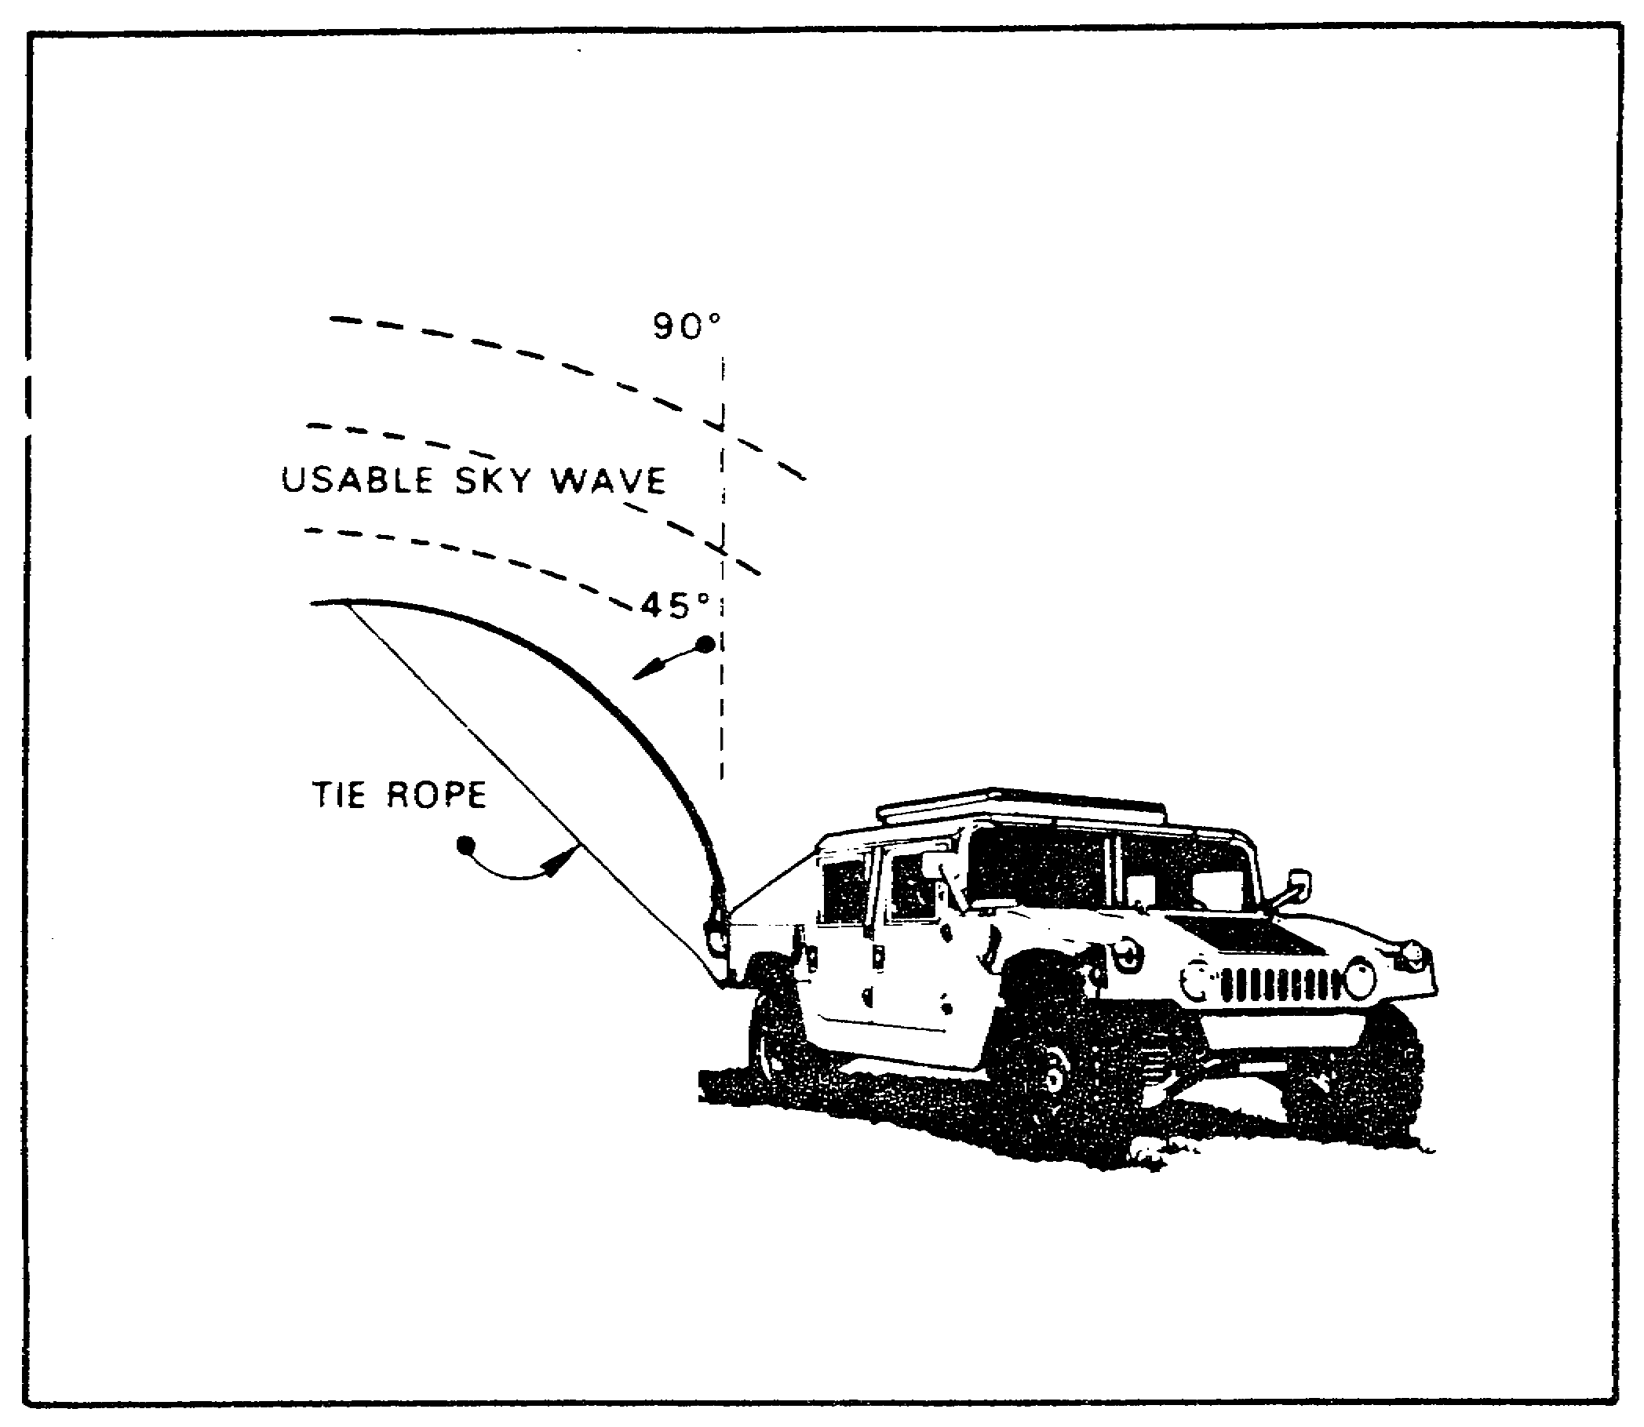
FIGURE 23. WHIP ANTENNA TIED BACK FOR SKYWAVE.

2. COUNTERPOISE - As mentioned earlier, the counterpoise is an artificial ground surface, constructed of wire, that is mounted underneath the antenna. It is used when the ground surface under the antenna has poor conductivity or is too dry. Counterpoises are not normally needed for whip antennas because the vehicle body acts as a counterpoise. For it to work effectively you must ensure the following:

a. The counterpoise is at least as long as the antenna.

b. It is mounted under the antenna and several inches above the ground.

c. It is insulated from the ground. See Figure 24.

d. For safety, ensure that the counterpoise is clearly marked and that all personnel on the site know where it is.

48

Lesson 3/Learning Event 3

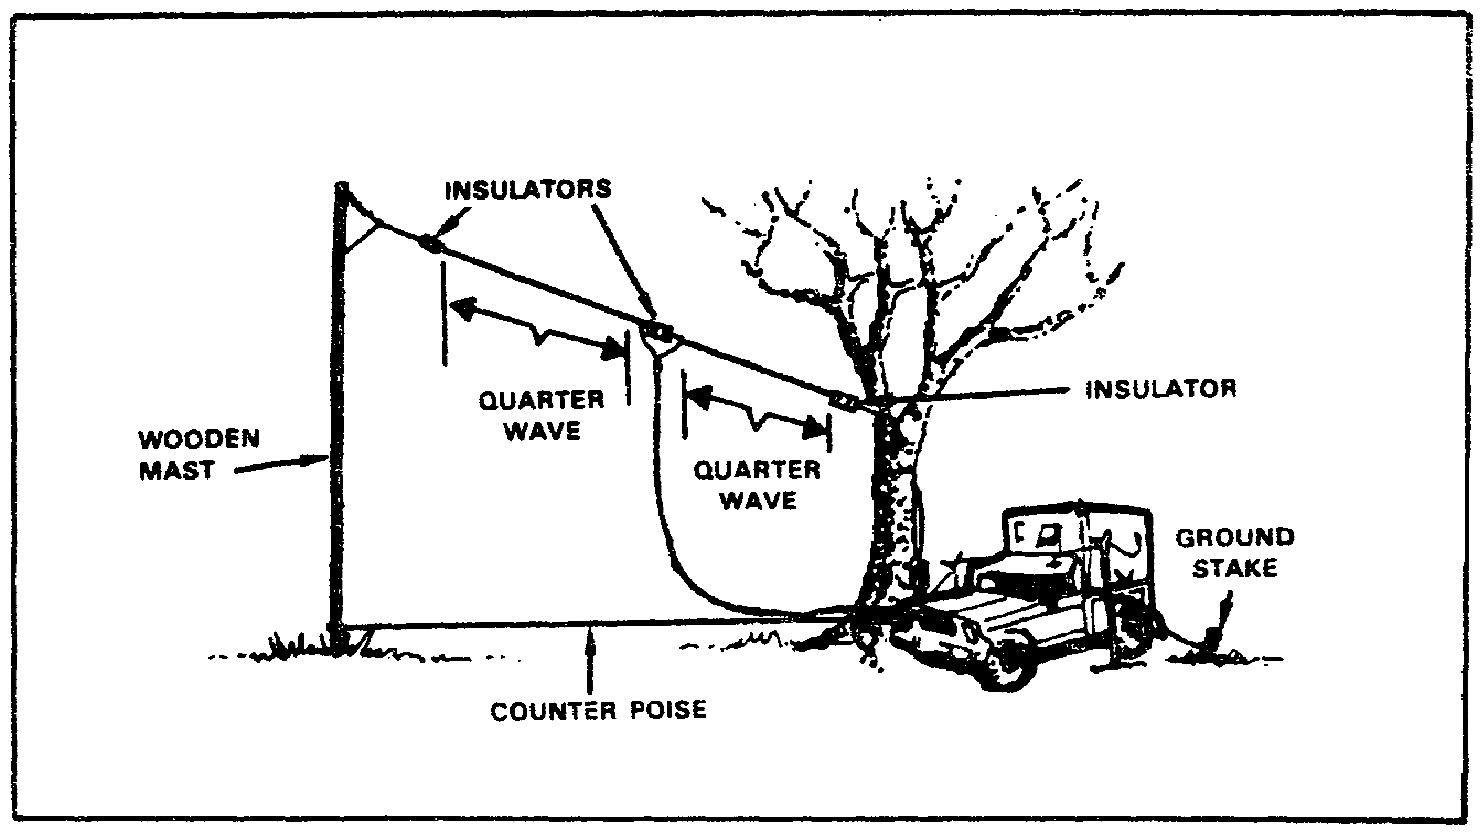

FIGURE 24. HALF-WAVE DOUBLET ANTENNA WITH A COUNTERPOISE.

3. INVERTED V - This is a modified doublet antenna. See Figure 25.

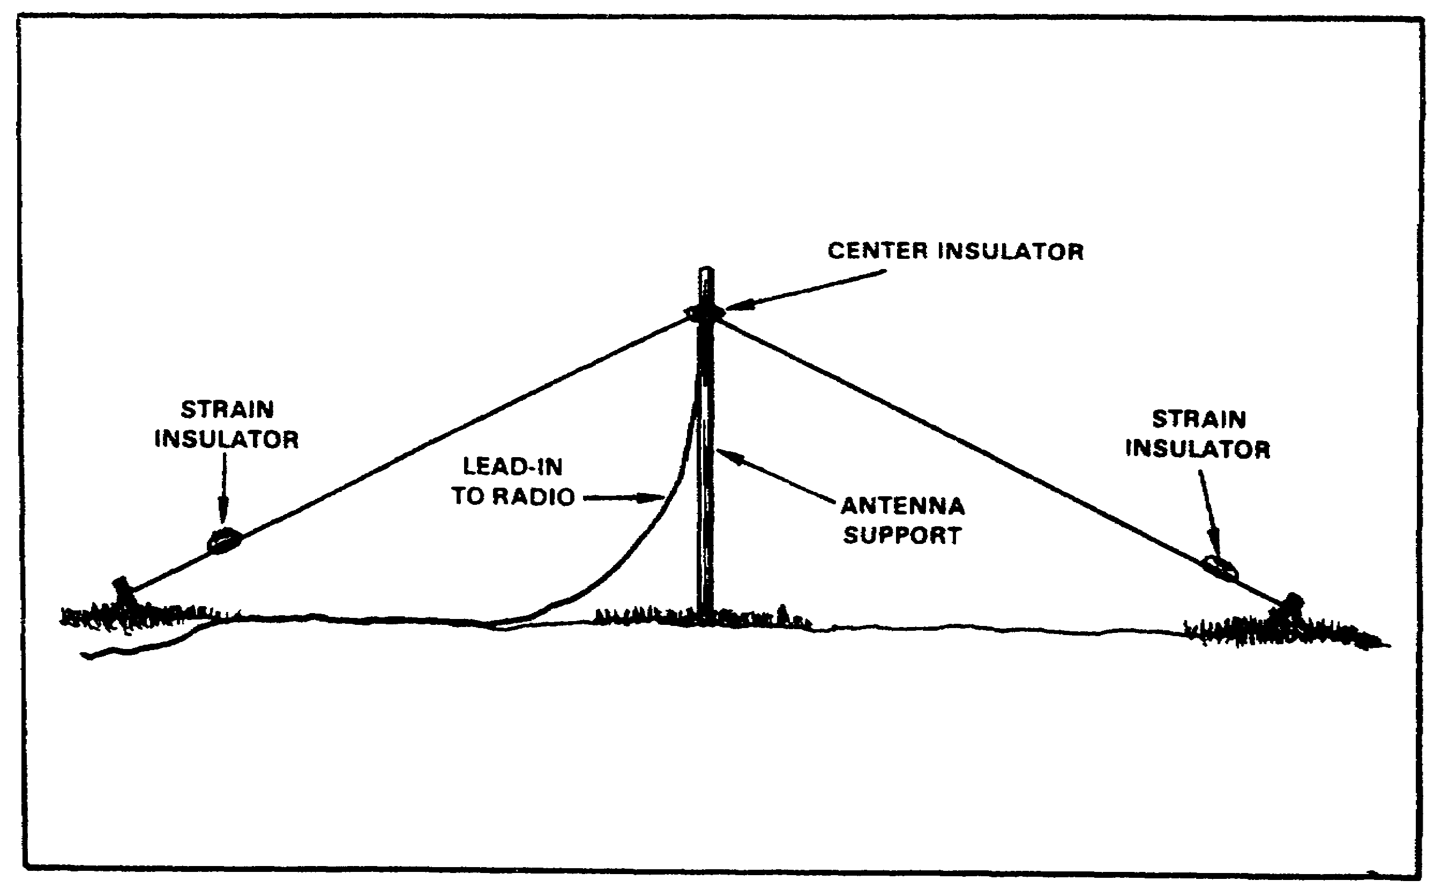

FIGURE 25. INVERTED V ANTENNA.

49

Lesson 3/Learning Event 3

a. You need to ensure that the length is calculated properly. The formula is the same as that of a doublet:

Length in feet = 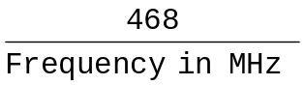

b. You need to ensure that the ends of the antenna do NOT touch the ground, because if they do the antenna will not work properly and you may cause damage to the radio set.

c. Since the ends of the antenna will be close to the ground surface, for safety you need to ensure that the areas where the antenna ends are tied down are clearly marked.

d. Do not allow the antenna wire to come in contact with trees, leaves or other foliage.

4. NVIS - The NVIS principle can be applied to just about any common antenna you will use, except certain highly directional antennas, such as the long wire. NVIS can be applied to any type of doublet, and even to a whip.

a. APPLYING NVIS TO A WHIP - As discussed earlier, tying a whip antenna back, away from the body of the vehicle, causes the whip to act as part of an unbalanced dipole antenna. The vehicle body acts as the other half. By doing this, you can take some advantage of NVIS, but this is a very inefficient configuration. If you must communicate on the move, then you must tie the whip ACROSS the vehicle body. You may still be able to take some advantage of NVIS, but this configuration is even more inefficient.

b. APPLYING NVIS TO DIPOLE TYPE ANTENNAS - Dipole type antennas are the type of antennas that show the most effect from applying NVIS. When a doublet, for example, is installed between 1/10 and 1/4 wavelength above the ground, it directs most of its energy toward the zenith. If you wish to take advantage of NVIS with your dipole type antenna, you must ensure the following:

(1) The antenna must be less than 1/4 wavelength above the ground.

(2) You should select a site for your antenna that keeps ground wave radiation to a minimum. This is to prevent interference between the sky wave and the ground wave.

(3) If you have a choice, avoid frequencies that have a lot of natural or man-made radio noise.

(4) Take advantage of terrain features to block jamming signals.

50
Lesson 3/Learning Event 3

(5) If the antenna is close enough to the ground that it poses a safety hazard, ensure that the antenna is marked and everyone on the site knows where it is located.

(6) An antenna using NVIS is essentially omnidirectional, therefore antenna orientation is NOT critical. However, if you are operating within about 500 miles of the magnetic dip equator (Figure 26), you must orient your dipole antenna magnetically North-South to ensure adequate receive level.

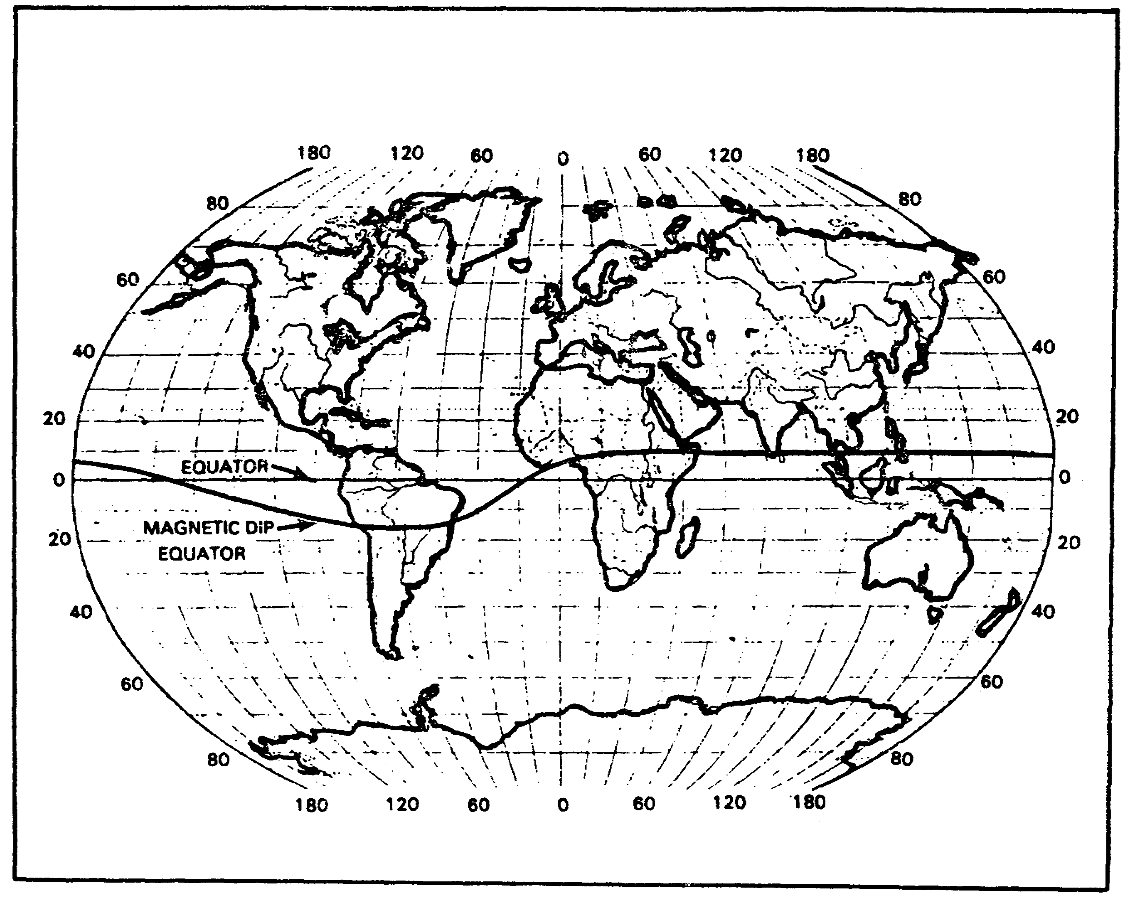

FIGURE 26. MAGNETIC DIP EQUATOR.

5. LONG WIRE - This is a directional, vertically polarized ground wave antenna. It requires a very large area to be installed.

a. You will need the following materials and equipment to construct and install it:

(1) Sufficient wire for the length of the antenna. Any type of wire will do, but insulated wire, such as WD-1/TT, is easier to

51

Lesson 3/Learning Event 3

work with because it is easier to prevent inadvertent short circuits.

(2) A compass to determine the proper azimuth.

(3) Enough supports to keep the antenna in the air. There should be one support for each 80 to 100 feet of wire.

(4) At least one insulator for each support you will be using, plus one insulator for each end of the wire. These will keep the antenna wire from touching the supports.

(5) A tape measure.

(6) One 500 to 600 ohm noninductive terminating resistor (optional). If this resistor is used, it must be capable of absorbing at least 1/2 of the transmitter power.

b. The steps for construction and installation are:

(1) Determine the number of wavelengths long that you want your antenna to be. The minimum length for a longwire antenna is one (1) wavelength. The antenna becomes more directional as the length increases. If you desire a longer antenna, you must increase the length by complete half-wavelengths. This means that your antenna can be 1, 1 1/2, 2, 2 1/2 wavelengths, and so on.

(2) Calculate the length of the antenna using the formula

Length (in METERS) = 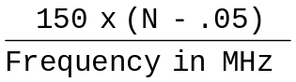

or
Length (in FEET) = 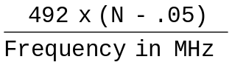

where N = number of HALF-wavelengths in total length of the antenna (multiply the number of wavelengths by 2 to obtain the number of HALF-wavelengths).

For example, if the desired number of half-wavelengths is 3 and the desired frequency is 7 MHz, then:

Length (ft) = 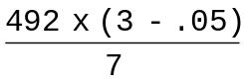 = 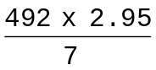 = 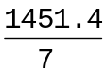 = 207.34

(3) Determine the azimuth to your distant station and measure out your wire in this direction, ensuring that the wire is all in one piece, not broken. Splices are OK, as long as there is a good electrical connection.

52
Lesson 3/Learning Event 3

(4) Assemble and erect your supports about every 80 to 100 feet along the length of your wire. Suspend your wire from the top of the supports, ensuring that you use insulators to prevent the wire from coming into contact with your supports. Your antenna wire should be between 3.5 and 4.5 meters (12 to 15 feet) above the ground.

(5) If you are using a terminating resistor, connect the far end of the wire to your terminating resistor (see Figure 27). If you are NOT using a terminating resistor, secure the far end of the wire to your farthest support using an insulator (see Figure 28).

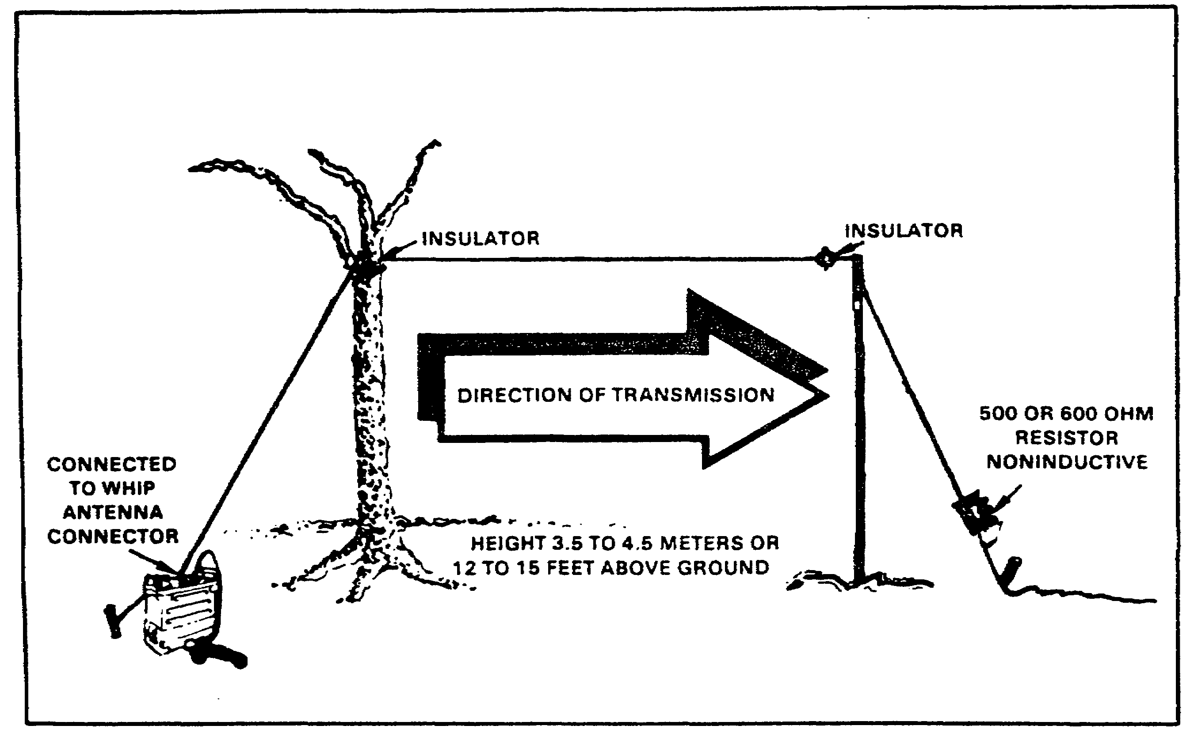

FIGURE 27. LONG WIRE ANTENNA WITH TERMINATING RESISTOR.

53

Lesson 3/Learning Event 3

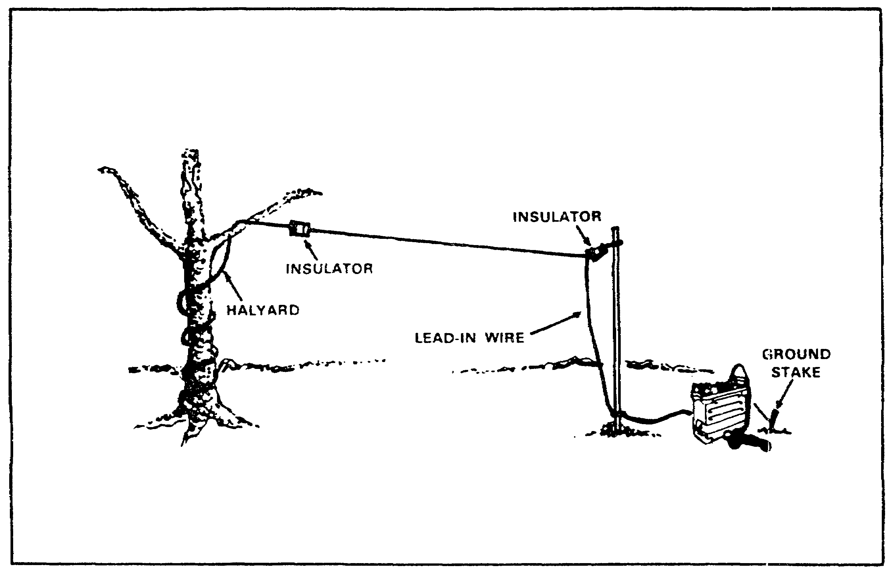

FIGURE 28. LONG WIRE ANTENNA WITHOUT TERMINATING RESISTOR.

(6) Attach the near end of the wire to the connector for your whip antenna.

6. FAN DIPOLE - This multiple frequency antenna can be erected in the same manner as a standard doublet to communicate on long skywave paths, or it can be erected using NVIS principles to allow continuous communications out to a distance of 300 miles or so. See Figure 29.

a. You will need the following materials to construct the fan dipole antenna.

(1) Sufficient wire to construct half-wave antennas for ALL of the frequencies you desire to operate on.

(2) One RF coax cable, such as the CG-678 used for the AN/GRA-50 antenna or the CG-692.

(3) Two strain insulators for each antenna, and one center insulator, such as the IL-4/GRA-4. If you are using the CG-692 you will not need a separate center insulator since one is already part of the cable assembly.

54
Lesson 3/Learning Event 3

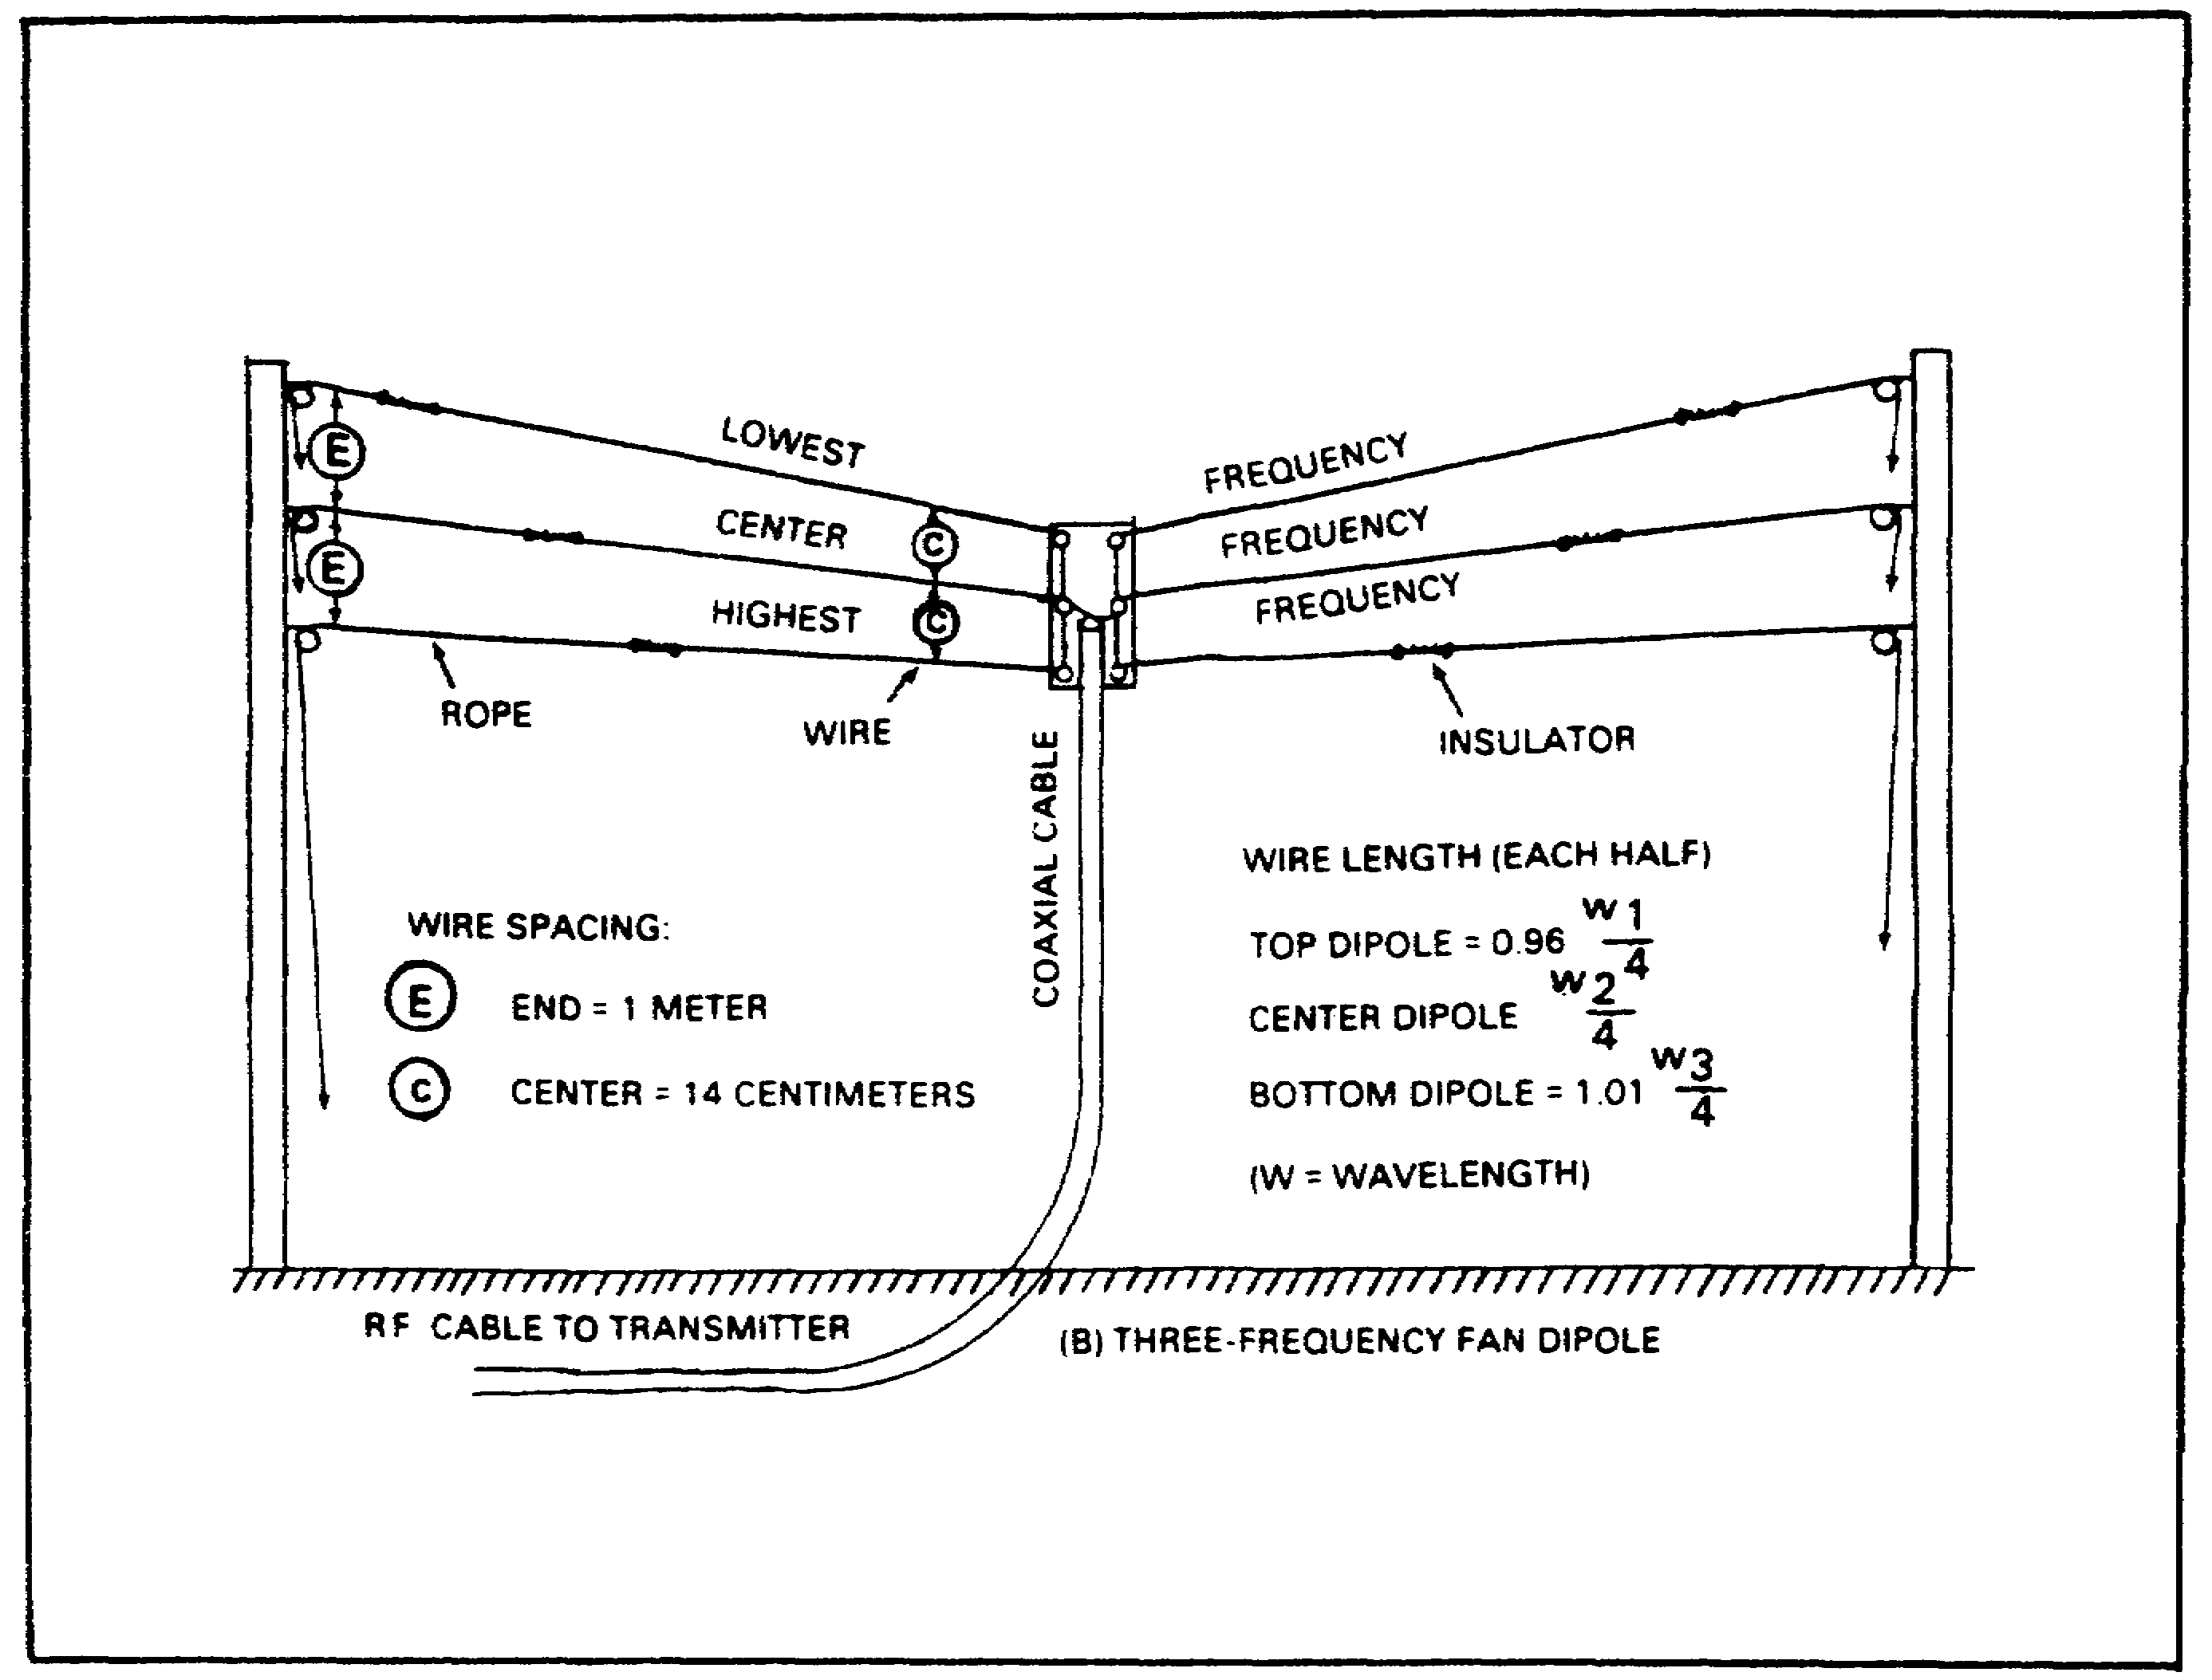

FIGURE 29. FAN DIPOLE ANTENNA.

(4) Two halyards for each of the antennas, and one for the center insulator.

(5) A measuring tape.

(6) At least two antenna supports, but preferably three.

55

Lesson 3/Learning Event 3

b. Steps for construction and installation. (See Figure 29.)

(1) Determine the lengths of each antenna using the formula

Length (feet) =

and then multiply the results for each antenna as follows to find the overall length for each frequency:

(a) Lowest frequency: Length x 0.96.

(b) Middle frequencies: Length remains the same.

(c) Highest frequency: Length x 1.01.

Then divide these results by 2 to find the length for each side of the antenna for each frequency.

(2) In order, starting with the LOWEST frequency, construct the antenna for each frequency in the following manner:

(a) Measure out the wire for the antenna, including extra wire to allow for tuning and adjustment, and then cut the wire in half.

(b) Connect one end of each piece of wire to the center connector, making sure that the connection is mechanically strong.

(c) Connect the other end of each wire to a strain insulator, and then connect the strain insulator to the halyard.

(3) If you are using an IL-4/GRA-4 as your center insulator, connect the RF cable to it.

(4) Once all of the antennas have been constructed and attached to both the center insulator and the strain insulators, raise the completed assembly to the operating height. Ensure that the ends of the antennas that are attached to the halyards are separated by about 3 feet or 1 meter from each other.

(5) Connect the other end of your RF cable to the doublet antenna connector on your radio set.

(6) In order, starting with the LOWEST frequency, tune your radio into the antenna and check the Standing Wave Ratio (SWR). If necessary, make any adjustments to the antenna to bring the SWR into an acceptable range. Adjust ONLY the antenna that corresponds to the frequency you are operating your radio on.

56
Lesson 3/Learning Event 3

CAUTION

BEFORE MAKING ANY ADJUSTMENTS TO THE ANTENNA, ENSURE THAT THE RADIO IS PLACED IN THE STANDBY MODE OR IS TURNED OFF, AND THAT THE RF CABLE IS DISCONNECTED FROM THE RADIO. THIS WILL PREVENT INJURY DUE TO ELECTRICAL SHOCK.

c. Operating the Fan Dipole antenna - Operating this antenna is very simple. When it becomes time to change your operating frequency, just change the frequency on your radio and then retune the radio into the antenna. Provided you have adjusted the antenna properly for each frequency, you will not need to readjust the antenna as long as you remain on the frequencies it was constructed for.

57

LESSON 3

LEARNING EVENT 3

PRACTICE EXERCISE

(PERFORMANCE-ORIENTED)

TASK: Direct the construction and installation of field expedient HF antennas.

CONDITIONS: Given an azimuth, information extracted from TM 11-5815-334-10, FM 24-18 and TC 24-19, a pencil, and without supervision.

STANDARDS: Demonstrate competency of the task skills and knowledge by correctly answering 70 percent of the multiple choice questions covering directing the installation of field expedient antennas.

INSTRUCTIONS:

In each of the following questions, SELECT the one answer that BEST completes the statement or answers the question. Indicate your response by circling the correct letter below.

1. Under which of the following conditions would you direct your team to install a counterpoise?

a. Antenna too close to the ground.

b. Antenna too far from the ground.

c. Ground too dry.

d. Ground too wet.

2. Which of the following antennas can NVIS NOT be applied to?

a. Fan dipole.

b. Long wire.

c. Whip.

d. Inverted V.

58

3. You have constructed a fan dipole for the following frequencies. For which of these frequencies would you check the standing wave ratio (SWR) FIRST?

a. 4.885 MHz.

b. 5.935 MHz.

c. 7.903 MHz.

d. 9.556 MHz.

59

ANSWERS TO PRACTICE EXERCISE

(PERFORMANCE-ORIENTED)

Answers Reference

Lesson 1: Para Page

Learning Events 1-3:

1. b (Learning Event 1) 1c 2

2. d (Learning Event 2) 4a-c 3

3. a (Learning Event 2) 4d 3

4. b (Learning Event 3) 1a-g 5-9
Figure 6

Lesson 2:

Learning Event 1

1. c 1b 12

2. c 2a 13

3. d 1g 13

4. c 2c 13

Learning Event 2

1. c 2 17

2. b 3, 3c(5) 23, 26

3. a 2a(2)(b) 19

4. d 2b(2)(a) 21

5. d 3b(3) 24

60
Lesson 3:

Learning Event 1:

1. a 1b(1) 31

2. c 4 38

3. c Sa(4) 38

4. c 3b(1) 36

Learning Event 2:

1. a 5 42

2. c 3 40

3. b 4b 41

Learning Event 3:

1. c 2 48

2. b 4 50

3. a 6b(6) 56

61

